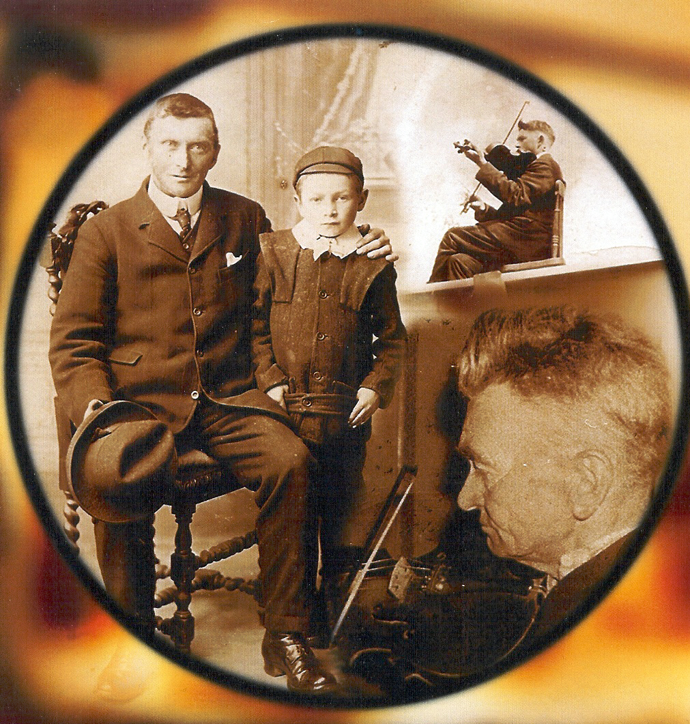

Aeroplanes out of Scrapheaps:

Patrick Kelly from Cree

Aeroplanes out of Scrapheaps:

Patrick Kelly from Cree

by

Brendan Taaffe

Student ID 0414735

Submitted for completion of the requirements of course module MU5601:
Repertoire, Style and Contextualized Performance
as part of the Master of Arts in Traditional Music Performance, Irish World Music Centre, University of Limerick

Acknowledgements

The completion of this project has taken the time and good efforts of many people, all of whom I would like to thank here. The family of Patrick Kelly was rich in hospitality, sharing generously of their father’s life and of freshly baked apple tarts. I would like to especially thank Tom and Jim Kelly for their assistance. I would not have found the Kellys were it not for the assistance of Barry Taylor, also extremely generous with his time.

In following leads and looking for information on Patrick Kelly and the music of West Clare, I turned to many people: Séamus Mac Mathúna, Matt Cranitch, Paul de Grae, Michael Tubridy, Caoimhin O Raghallaigh, Mick O Connor and Nicholas Carolan were all unstinting in sharing what they know.

It was Brad Hurley, those many moons ago, who gave me the second-hand copy of Ceol an Chlair.

Lastly, I would like to thank Niall Keegan and Sandra Joyce for their hard work and good humour at the Irish World Music Centre.

Introduction

There is a beauty and perfection in his music, born out of pure creativity rather than of the intellect. I feel if you were to give him a few bits of cast-off tunes, he would sculpt them into something that could fly—like making an aeroplane out of a scrapheap.

I am entranced by the music of Patrick Kelly, a fiddler from West Clare who died almost thirty years ago. His was a highly personal music—played mostly in the kitchen, on his own—and of a singular creativity, mixing wildness and sweet in crafting lovely versions out of common tunes. In this, Patrick’s playing was not unlike that of Tommy Potts, also a very individual and creative musician. There is an argument to be made that an art is defined not by the mainstream—amateur watercolorists painting the mountains of a weekend—but by the people on the fringes—Picasso stretching our concept of portraiture. Patrick didn’t alter the structure of a tune in the way that Potts did, but both put an unmistakable stamp on a tune, making it their own, and both are considered beacon musicians of the twentieth century, players regarded as exemplars of the tradition. Patrick mostly stayed at home and was little recorded, yet his influence can be heard in the playing of a number of prominent fiddlers, including Martin Hayes, Séan Keane, James Kelly and Caoimhin O Raghallaigh. It was a stroke of fortune for me to be given a copy of Ceol an Chlair, vol. 1 by a friend in Montreal some years ago. Ceol an Chlair, long out of print, is a legendary album issued by Comhaltas in 1979 featuring the unaccompanied fiddling of Bobby Casey, Junior Crehan, Joe Ryan, John Kelly and Patrick Kelly. I was already aware of Casey and Junior, but was completely taken in by the tracks of Patrick’s playing at the end of the album, a fascination that continues.
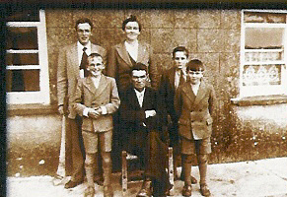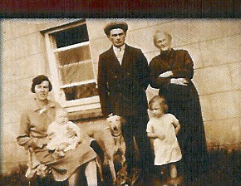

Life: Beginnings

Patrick Kelly was born in Cree, Co. Clare in 1905, the only child of Tim Kelly and Maria Killeen (1863-1951). Tim Kelly, born in 1866, played the fiddle and had been a student George Whelan, a traveling fiddler from Kerry who was in the area around 1880. Speaking to Mick O’Connor in 1972, Patrick said this about his father:

My father spent his life playing music, but he died young. I was young when he died. I had a certain amount got from him, such as the Foxhunter’s reel, and a lot of set pieces. But he had a lot of music that I don’t recollect at all. Or probably I did, but I being too young I didn’t learn any music.

Did he play the same style as Denny Mescall?

No, no he did not. Completely different style, I would be thinking. A different style of music. He was a great air player. He had a great opportunity: he had two sisters that were reared in the convent, or were educated in the convent, and they had all of Moore’s melodies and one of them was a noted singer. She was a noted singer and that’s how my father was such a great air player, because he was brought up with them two girls, more or less, which is a great advantage to know something about the song, for to play airs.

As well as fiddling and doing the work of a small farm, Tim Kelly was an active teacher and an ardent nationalist. Pupils would come to the house to learn music, giving Patrick an early opportunity to absorb the tunes. In conversation with Séamus Mac Mathúna, Patrick remembered his father’s lessons:

Would he have a type of people that come: was it young people who came?

‘Twould surprise you the advanced people that came, and people that I had no account of.

Had he a special time?

No, no – time didn’t matter in them days. Time didn’t matter.

Would he take them one at a time?

He’d take them single. Well, if they were good enough, which you often would have them. I could sit down in the corner on two stacks of turf, of course there was turf in every corner that time, and I could be sitting down over there, listening to him teaching the music, and I could play that when they were finished.

You started on the fiddle at what age?

Around ten.

The Foxhunter’s now, would he tune up the fiddle for that?

Oh, he would.

Would he give you lessons as well, or would you just pick it up?

Oh, he gave me lessons, he did. Such as that Apples in Winter, or Gillan’s Apples I should say, or the Ace and Deuce, things that I do remember. And the Job of course, but he played another tune then that I never heard, or knew anything about, The Downfall of Paris, which was this old one up in Glenbeg that heard it played on the radio years after he’d been buried, they told me that me father played it. ‘Tis in the book.

He taught two bands then, of course. He taught a band in the period, maybe around ’92 or ’94, and then another in 1917. He was a great nationalist, which very few of the Kellys were.

Tim Kelly died at 53 of unknown causes, 2 April, 1919. Patrick was 14 years old, and he and his mother relied on the help of neighbors to carry out the work of the farm, a system of mutual reliance that lasted for decades. Patrick’s son Jim spoke of how the community would come together to make the harvest last:

They’d all join, you see, to do the work. They shared the work. When the pig would be killed, people made what is known as puddings. The black pudding that you’d get here. The intestines were washed and cleaned out, and washed and re-washed, and then they’d be filled up with the blood. When it would be taken from the pig, they’d be kept stirring it and then you put in the oatmeal and onions and spices and fill the puddings. And they were boiled then, and hung up on a rack, or the handle of a brush across some chairs. And then some of the puddings would go to the neighbors all around, and a few slices of the pig, steak. And when the other person killed the pig then, you see, we got it back again. So you hadn’t a whole lot of it – for a long, long time you were in steak, you see, and fresh pudding. That was the way it went around. The same way it went with the cutting and putting in of the hay. People came and they made up the hay and you went then, my father was one for making the wynds, making sure they were straight. He had an eye for that, and that was his job in the hay-yard. He’d keep going all day, showing them where to hit down the hay, and he’d be raking around the side of it, keeping it.

Grown

Patrick married Margaret “Dilly” Golden from Cree around 1930. Their first child, a daughter, was born in 1931, with the family growing to seven children. “A small man, and slight,” Patrick was regarded a neat and tidy farmer, and was looked to by neighbors for advice and help.
People used take him into their confidence about things, neighbors. They’d be looking for advice, or maybe they’d be low on money. Whatever he had, he wouldn’t leave them short. I didn’t discover that until I was bringing a neighbor to hospital that had cancer, and ‘tis he told me about all the times my father helped him out with money.

House dances were common in Patrick’s younger days, and his son Tom had a number of stories about Patrick playing for dancers.
He’d go to town fairly often, cycling—there was no other way to travel at that time. Mitchell Lillis was a smith who lived in the village, just beyond the turn in the village. And he’d two big open doors on the forge, and he’d see everyone as they’d pass. So he’d see my father passing in the morning, and he’d have a set ready for the night then. Patrick Kelly has gone down today, there’s going to be a set at Jackie’s tonight. Jackie McInerny was his name, and the set would be there that night. Because Mrs. O’Keefe told me she often went up to the door at night to hear them dancing the set. There’d be a set there every time.

Tom went on to describe some of what would happen those nights.
I remember my father describing long ago, ‘tis an eye-lamp would be hanging up on the pier just behind him, with a globe on it and two wicks on it and that would be the lighting. There was no electricity you see, and he would be playing and of course he would never be blamed. He would be under it and up would go the bow and he’d just hit the globe and down the globe would come on top of him. But there was always someone blamed and never him. I often heard him telling that, and I heard him telling one night, there was two rooms, one room down there and the partition only went the height of the wall and there was a knee roof on the place. In the middle of the set one night, the tick and feathers came up over the top of it and landed in the middle of the floor on top of the lads that were dancing. The tick and feathers – they used to sleep on the bed—and a couple of lads took it from down below and flung it right out over and it landed right in the middle of the floor. Oh, what usen’t go on there. There was a hasp on the door, there was one of them on the door and, of course, a lad outside he put on the hasp and put a piece of tin through and, Jesus, you couldn’t get out, you’d have to go through a window. He used to be playing for the dances, one time.

In 1935 the Fianna Fail government enacted the Public Dance Hall Act, declaring that 'no place...shall be used for public dancing unless a public dancing license... is in force in respect of such a place.” A license was issued only to those whom a district judge considered of 'good character' and often licenses were refused to rural communities based on the difficulty of supervision. Even though the act did not specifically cover house dances, local clergy and gardai used it to ban these as well. Séamus Mac Mathúna had, “heard it being said that they felt that nights were being organized to support republican causes, but it was a damnable thing to decide. The government was supposed to be all Gaelic Ireland and all that: that they should, with the strong encouragement of the clergy, bring in this law that would end the house dances.” Séamus, living four miles away from the Kellys, can remember the last dance in his home being held around 1947, with house dances being almost extinct by the 1950’s.

Throughout his musical life, Patrick seems to have been a solo player. When I asked Tom Kelly if there were ever others playing with Patrick at the house dances, he replied that, “I never heard him saying there was anyone else there.” In the absence of dances, Séamus Mac Mathúna remembered that there were plays in parochial halls where musicians would play.
I recall numerous nights in Cooraclare as a young fellow, the likes of Solus Lillis, Jer O’Sullivan, Tommy Carey, and a whole lot of people only slightly older than myself would be playing. Paddy Breen if he was home. I don’t think Patrick played at such functions very much – I couldn’t be sure now. I certainly don’t recall it.

Given certain hallmarks of Patrick’s style—the uniqueness of his settings and the fiddle tuned low—it makes sense that he was primarily a solo player. There were, however, a few ensemble opportunities: Patrick recalled his father teaching two bands, a Land League band in 1892 and a Sinn Fein band in 1917. There was also a Cree Ceili Band, apparently short-lived, that Patrick took part in. Tom Kelly recalled the last appearance of the band at a football match in the 40’s, and went on to describe the members:
They had fiddles in it; Micky Kelly I remember. Tommy Golden, he was in it, my uncle. He played the drums. I don’t know if they have any picture of it. ‘Twas the first band ever to broadcast on Radio Eireann was the Cree Ceili Band, and it was done below from the town hall, through the phone. And Mrs. Crotty was inside in the pub and she went out to tell them to tune down the drums that they were smothering the music with it. ‘Cause she could hear it on the radio inside.

Who else was in the band?

All that crowd now. Probably Paddy McInerny and Paddy Cunningham, Tommy Golden and my father and all that crowd. And I think a couple from Kilrush played with them that are dead and gone now.

RTÉ’s early live broadcasts were not preserved, so it’s impossible to verify Cree’s claim to fame. No mention is made of the band in other sources, and it would seem to have been of minimal influence on Patrick’s style and approach to music.

In addition to the fiddle, Patrick played some whistle and could “knock a rattle” out of an accordion. He had a keen interest in other traditional players and strong opinions, holding that the introduction of Coleman’s 78s damaged the local tradition. “[Coleman] was wonderful, but that was the downfall of traditional music in the country. Before those days we had two, three, four or five fiddlers in Cree, now there isn’t one.” Patrick held strong opinions and was possibly a bit feisty. When Susie May, Patrick’s eldest daughter, brought some contemporary 78s into the house, they met an ignoble fate:
There was fellow used to repair bicycles, just above Cree, Bill Green was his name. And he started selling records, and Susie May went back and bought a record one day. ‘Twas burned. My father burned it, that’s a fact. It didn’t last long.

Did you have a record player?

Oh we did. A gramophone.

I’m surprised your father let a gramophone in the house.

Oh, the gramophone was there.

But you wouldn’t have had 78s of Coleman and Morrison in the house.

Oh, there was, yeah. I don’t know; he probably bought them. He’d allow them fine, but there was no way Buttons and Bows would come in to our house. About the only thing he listened to on radio was the news and Irish music.

Would he listen to Ceili House and the other programs?

All that, and he had his tape recorder ready, his small Grundig, with three inch tapes above on the top of it. And he’d be taping different bits of music all the time.

Patrick wasn’t a man for traveling, or for drink. He didn’t teach regularly, though there were a few young players, like Séan Keane and Mick O’Connor, who would call to the house to pick up some tunes. None of the seven children play, and Patrick felt that music had taken him away from his responsibilities.

He didn’t want you all to play because he didn’t want you coming in at all hours?

He didn’t want us coming in in the morning, falling about the place. No.

While other musicians of the time traveled to Fleadhs, Patrick preferred staying at home, though he did make it to the Fleadh in Kilrush in 1963. Jim Kelly remembers that his father would always make time for playing, even during the farming season.

He’d never work late. He’d always finish – well the cows would have to be milked in the evening, but he’d always finish in fair good time, unless there was rain promised or something and we were making up hay, he wouldn’t stay out too late. He’d come in there and I can see him sitting down there in the corner, that corner there, by the wall. We had an open fire, a big open fire before we put in the range. And he’d sit into the corner there and he start to play, and he’d play away for the night, every tune he had. He’d never go back over one he had played, he’d play away for the whole night.

Patrick took great enjoyment from his encounters with other musicians: Mrs. Crotty was not far away, and Patrick was a frequent caller. One visit is particularly legendary in the minds of the family: this account is from Tom Kelly.

He described one day going down to Kilrush with a toothache, a terrible bad toothache, so he decided that he’d go down and have it drawn. He was just going around the corner of Crotty’s below and he sees this man on a butter box playing the pipes. He pulled up beside him and stayed with him for a while and who was it but the famous piper in Dublin that the wall fell on him – Johnny Doran. So they went into Crotty’s and spent the rest of the day and a good part of the night and then came home after that, and he came home with the tooth and it was buried with him.

Patrick was clearly impressed by Doran’s piping, going as far as saying that Doran was a better piper than Garrett Barry.

John Harrison invited Johnny Doran for a night’s music, and he did arrive in good time. The house was full, street was full, everywhere was full, but an act of parliament had been passed here, I think by the Fianna Fail government at that time, that allowed only about 30 people in a house for entertainment, a dance. I think around 30 people. And guards landed in due time out there, and cleared the whole goddamned place, but Harrison brought him again, and he said that he was a better piper than Garrett Barry.

Other stories show the central role of music in Patrick’s life, something that would take him away from a harvest or keep him out until the morning.

I remember one particular day, we were at home and we had about ten acres of hay down, just west of the school there, and there was no way for turning hay or making hay. ‘Twas all hand fork – turn the hay and rake it in with a rake and get a horse and put it into the trams and bring it home. But three or four fellows came, they were Australians, fiddle players, and they came into the meadow above and we were all there, and they were talking away for about quarter of an hour and the next thing you know he stuck the fork and went off and we didn’t see him for two days. We were left saving the hay. Ah, it was something that would take you away every now and again. He didn’t come home until all hours of the morning. He didn’t want us to learn music because he saw what it done to himself and to other people. They stayed out, they stayed out until morning. Because I remember my mother describing looking out the window one morning, waiting for him to come home and bring in the cows to get them milked. And she looked out and there he was out on the road, sitting up on the pier of the gate, in the morning, and there was a fellow that lived in the house right across the road from us. And he was a step dancer by the name of McInerny, nothing to Paddy now, but he was on the road dancing. And this was before the road was tarred now, and my mother could see the dust coming up over the fence. Wasn’t that some picture? Of a six o’clock in the morning, of a fine summer’s morning, and she could see the dust coming up, and he above only playing the fiddle and your man dancing out on the road.

Endings

His main interest in life was music, so he would have been listening to anything that was on the radio, and he’d be impatient to start talking. In the ‘60s he would generally be sitting by the fire, but by the ‘70s, the last five or six years, he was usually in bed.

Having suffered from emphysema for a number of years, Patrick Kelly died in 1976, at the age of 71. Given his proclivity for staying home, his music would have remained little known had it not been for the work of two collectors: Seán Ó Riada and Séamus Mac Mathúna. Ó Riada recorded Patrick in 1961 for Our Musical Heritage, a RTÉ program that showcased different regional styles. Ó Riada had heard of Patrick from his father, Seán Reidy, who was originally from Kilmihil and had once studied the fiddle with Patrick. Our Musical Heritage was Mac Mathúna’s first exposure to Patrick’s playing, in spite of the fact that he had grown up in such proximity, and led him to record Patrick in 1966 and ’67, tracks of which would later be used on the compilation Ceol an Chlair. Outside of Ó Riada’s program, Patrick did not have any other radio appearances, something the family chalks up to poor relations between Patrick and Ciarán Mac Mathúna, the major radio presenter for traditional material at RTÉ. In 2004, the Kelly family brought out a CD of remastered home recordings that had been done by Tom Kelly in the ‘60s and preserved by Monsignor Martin O’Dea, of Tullabrack.

Music: Influences

Patrick learned his early music from his father Tim, who had, in turn, been a student of George Whelan. As described earlier, Patrick sat in the corner, on a stack of turf, while his father was teaching tunes to local students, absorbing the music. He had lessons with his father, starting around the age of 10, and retained a lot of his father’s repertoire.
Such as that Apples in Winter, or Gillan’s Apples I should say, or the Ace and Deuce, things that I do remember. And the Job of course, but he played another tune then that I never heard, or knew anything about, The Downfall of Paris, which was this old one up in Glenbeg that heard it played on the radio years after he’d been buried, they told me that me father played it. ‘Tis in the book.

Tim Kelly is rumoured to have taught a specific bowing to each tune, but my only evidence for this is second-hand accounts of conversations with Patrick. Of his father’s teaching, Patrick did remark that he was, “very particular about the bow hand.”

George Whelan remains a somewhat mysterious figure in the account: we know that he was from North Kerry, near Ballyduff, may have been blind, and may have had a brother who was a piper. Whelan taught in Cree, Cooraclare, Doonbeg and Kilmihil in the 1880’s, and would have taught Denny Mescall as well as Tim Kelly. Clearly he was a remarkable player, for his memory remained important to Patrick, born some 25 years after Whelan visited the area. Patrick spoke of Whelan and Mescall (ca. 1850-1934), whom he remembered as a great friend and good player.
Yes, I would say that [the music of West Clare] has origins in Kerry because my father got a heap of music from George Whelan, the blind fiddler that came in from Kerry, maybe 80 years ago or thereabouts. And he left a lot of music here in West Clare, but he didn’t go north, never went into Miltown, which surprises me. But he would have stayed a very long time here because a good part of the music in West Clare that I heard was played and taught by George Whelan. I saw and heard and played with a blind man by the name of Schooner Breen, that’s buried thirty or thirty five years, probably, and he wasn’t a great player, but he had a lot of music that he got from George Whelan. Played on the fiddle. Then I heard from my great friend Denny Mescall that every tune he got was from George Whelan, every tune he was able to play was from George Whelan and I don’t believe that he ever altered a note.

Denny Mescall taught in the locality, but Patrick doesn’t mention being a student of Mescall’s.

You knew Denny fairly well, I suppose.

He was the best of them lads I knew because the rest of them were dead when I was getting strong, and Denny was alive. And I knew the Schooner, the Schooner he got small pox, but that he remembered to see the birds. Remembered to see the birds, he was three years of age.

Denny Mescall, did he teach many himself?

Oh, he taught. Didn’t he walk back from where he lives to the Protestant church in Kilkee to teach Magrue’s wife music, two bob a tune. And you can put that down anyway to about 14 miles a day. That’s a long run. Well, he done that.

The one thing Denny didn’t do, or that he did do, he always insisted on leaning on the bow. He was a small bit deaf, and the majority of the fiddlers he left were all a bit on the rough side.

Outside of his father and Denny, Patrick would have had contact with a small number of highly skilled players. Tom Kelly recalls Willie Clancy being a regular caller to the house, and Mrs. Crotty being a great friend. Patrick himself spoke highly of a number of musicians, including Tomeen O’Dea, Daniel McNamara, Johnny Doran, and Garrett Barry. Patrick held a special regard for Thady Casey, a good friend; “I thought that he was very good, and that tradition went dead in West Clare when Thady died.”

Repertoire

Of the available recorded tracks of Patrick’s playing, the majority of his tunes were reels and most of these are widely known: Bonny Kate, The Flogging, Paddy on the Turnpike, Sheehan’s, The College Groves, Fermoy Lasses, The Maid Behind the Bar, The Morning Star, The Salamanca, The Star of Munster, The Bird in the Bush, the Mason’s Apron, Drowsy Maggie, The Bucks of Oranmore, The Milliner’s Daughter and The Foxhunter’s. Though the tunes are in common circulation, Patrick’s settings are unique, as the transcribed examples of The College Groves, The Salamanca, and Drowsy Maggie demonstrate. When Patrick spoke of Denny Mescall he made the comment that Denny “played tunes exactly as he got them, which would have been a criticism”.

From that comment, and the evidence of his playing, it’s clear that Patrick valued the personal interpretation of dance tunes. A look at Patrick’s setting of Drowsy Maggie may shed light on this aspect of his music. Patrick’s setting of the tune is very close to Mrs. Crotty’s playing of The Reel with the Birl, her distinctive rendition of Drowsy Maggie. Of the transcriptions that follow, Patrick’s version of the tune is first and Mrs. Crotty’s second: I have transposed Mrs. Crotty’s version from the original key of A minor for ease of comparison. We can see that the basic motif of the A part is the same between the two versions, but bars 3 and 7 show definite departures. The B part of the tune has significant variation; particularly at bar 9, where Patrick alters the contour of the melody as it moves to the E; at bar 11, where the rhythm and melody of the tune are altered; bar 12, where the contour is again changed; and in bars 14 and 15 where the melody is different altogether. As Mrs. Crotty is held to be the source of the tune, the differences between the two versions show Patrick’s creative process at work, adapting a tune to fit his instrument and personal style. By inference, we can assume that the same creative process was at work in his other settings, many of which are unique.

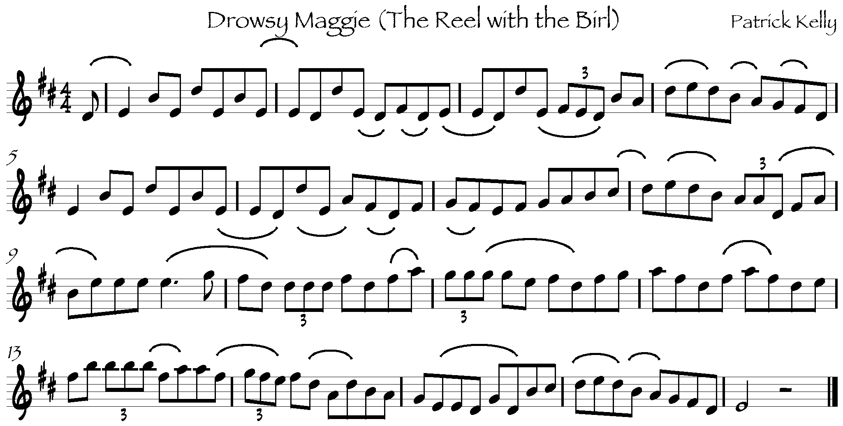

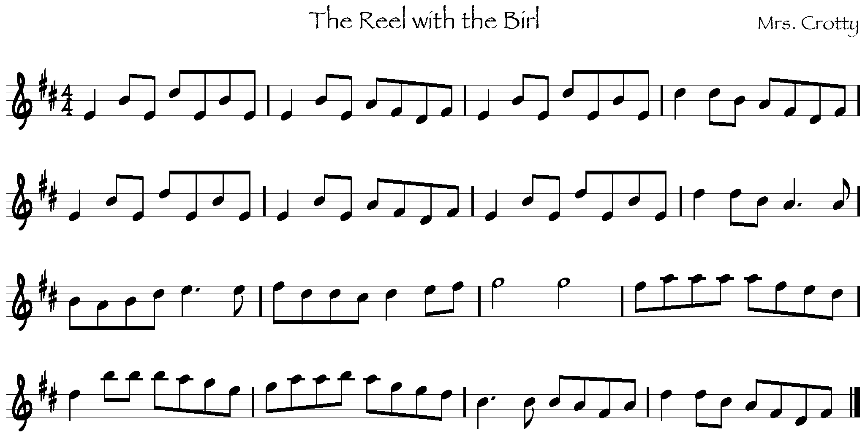

Jigs are next in prominence, with recorded examples including Banish Misfortune, The Frieze Britches, The Geese in the Bog, Sweet Biddy Daly, and Gillan’s Apples. In Séamus Mac Mathúna’s opinion, Patrick was at his best playing jigs. “I would think that from the fluency with which he played some of those jigs that he was putting a fair bit of his own creative thing into it, just from the kind of momentum and vehemence, if you like, that was in the tune.” Certainly, the use of quadruplets, as in Banish Misfortune (bar 9) and the Frieze Britches (bar 49), is one of the most spectacular features of Patrick’s playing. He plays four notes in the space of the usual three, giving the tune the effect of a “broken” rhythm, though the pulse remains steady across the ornament. The notes of the quadruplet figure are the same in both tunes, suggesting that Patrick took the ornament from one to the other.
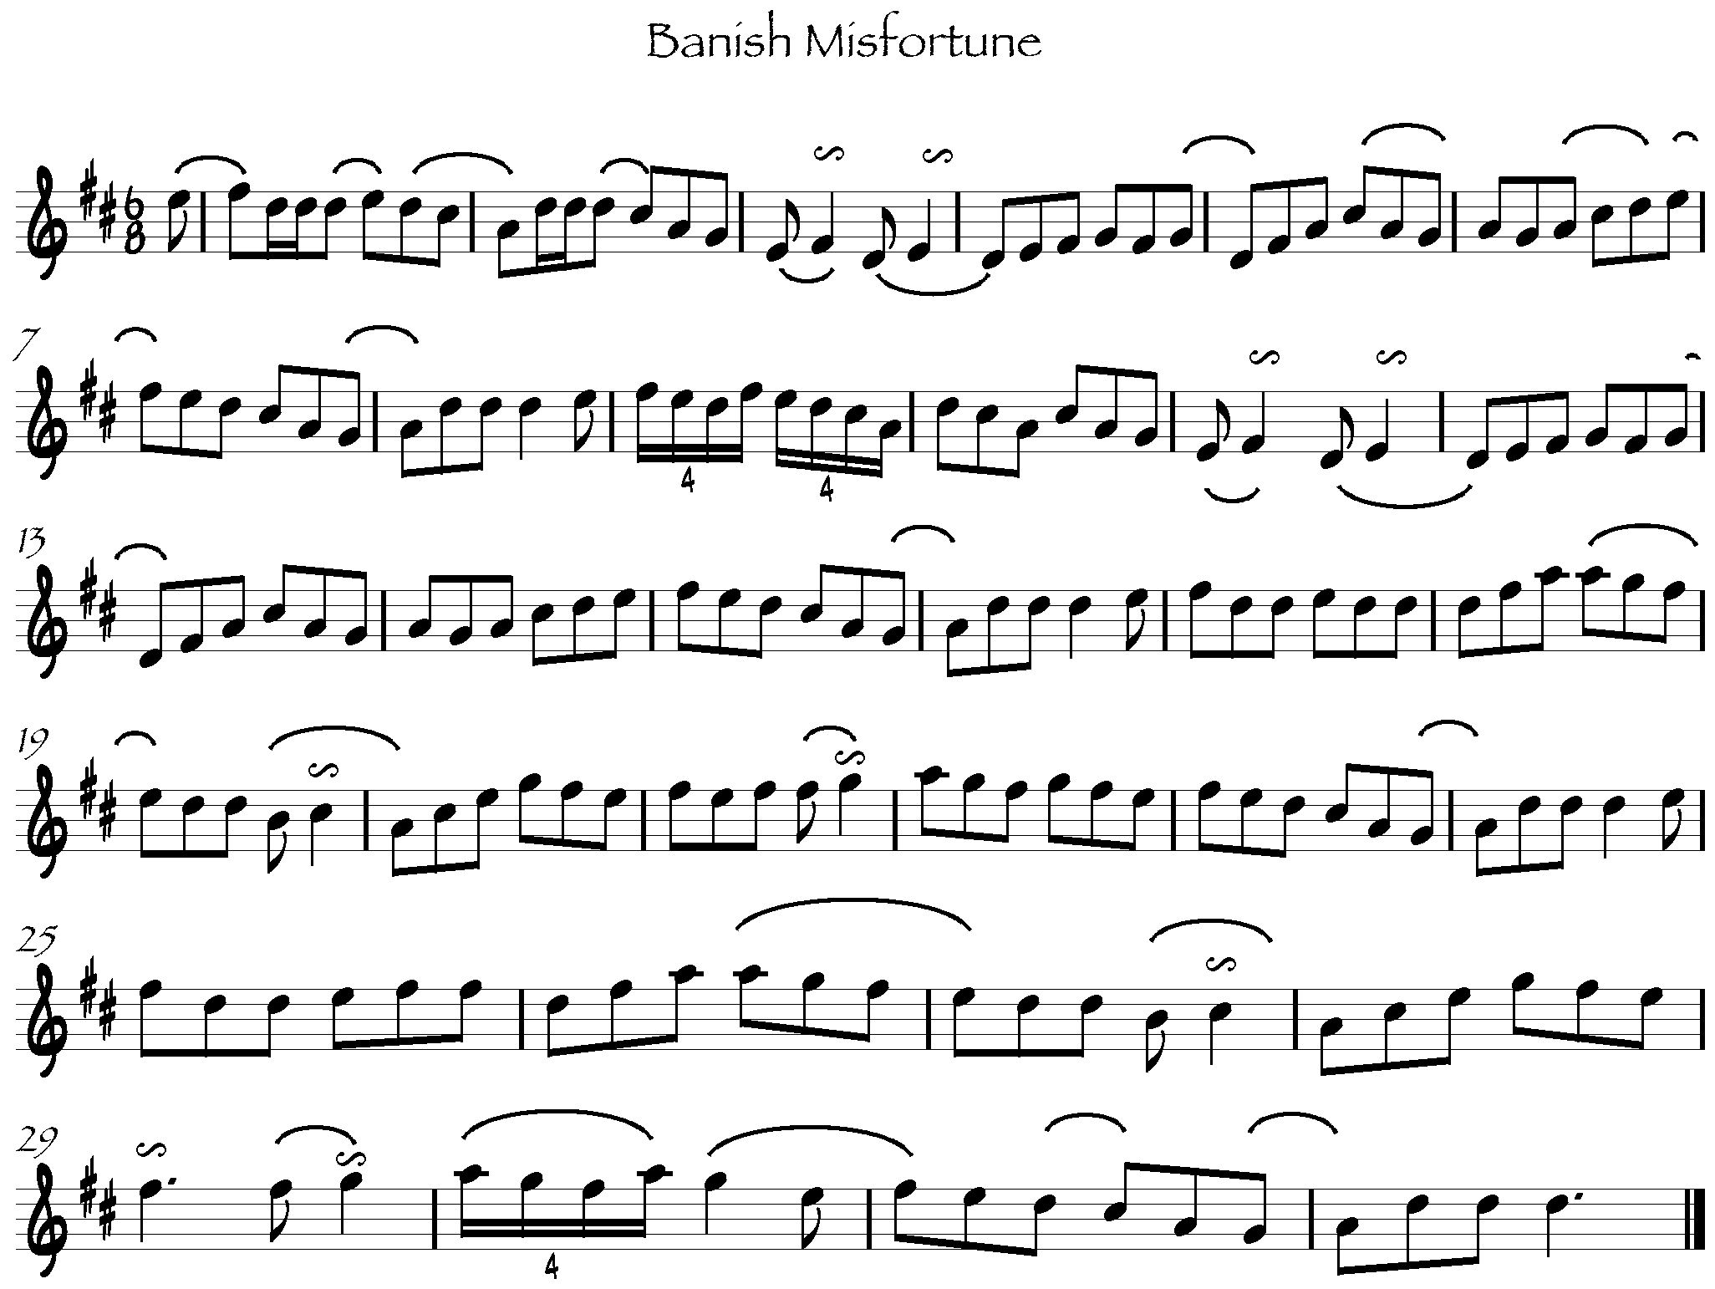

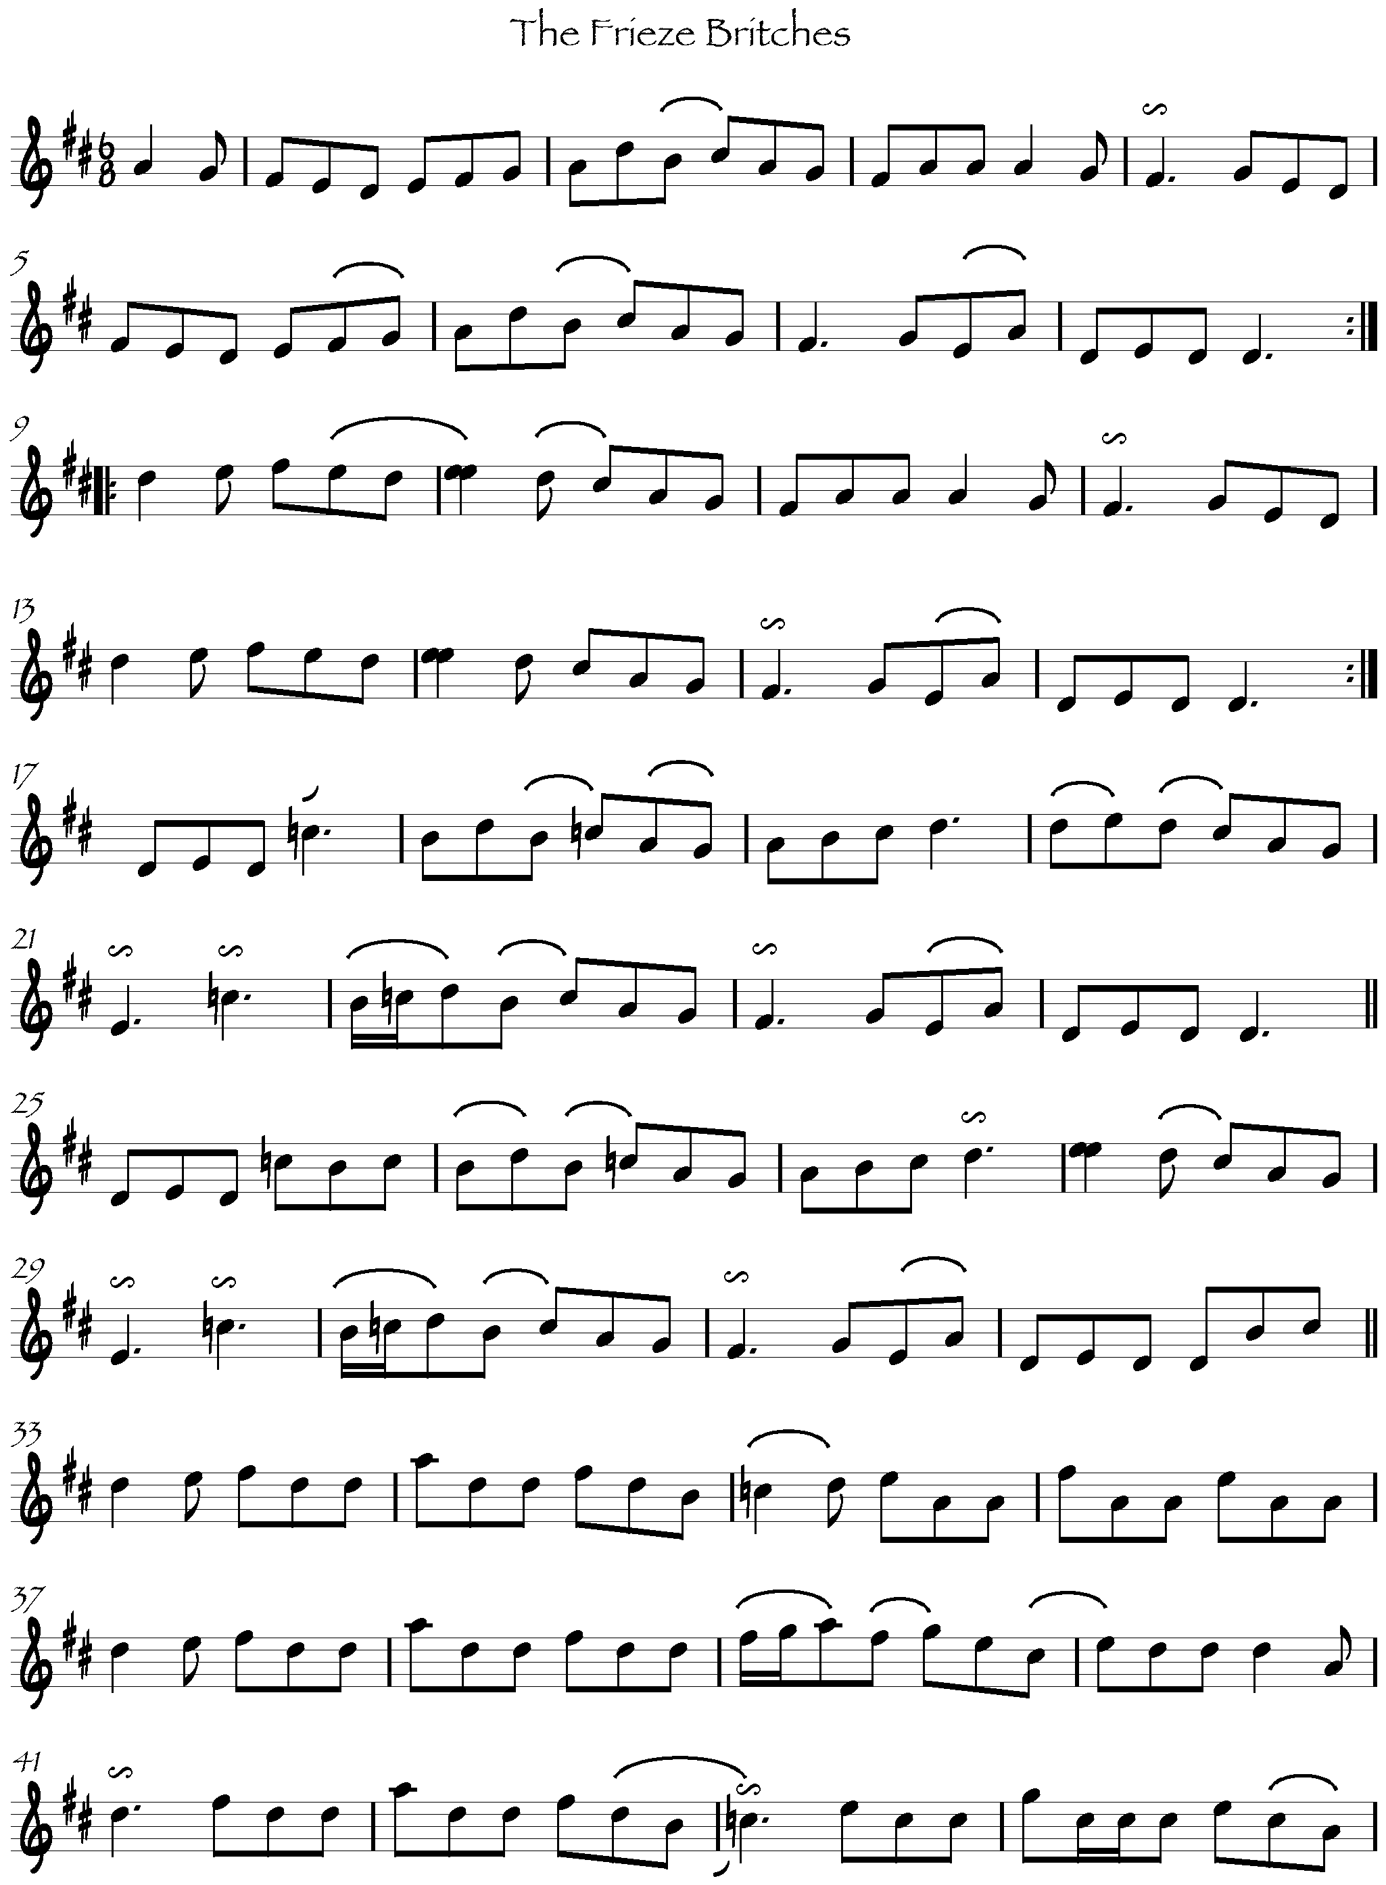

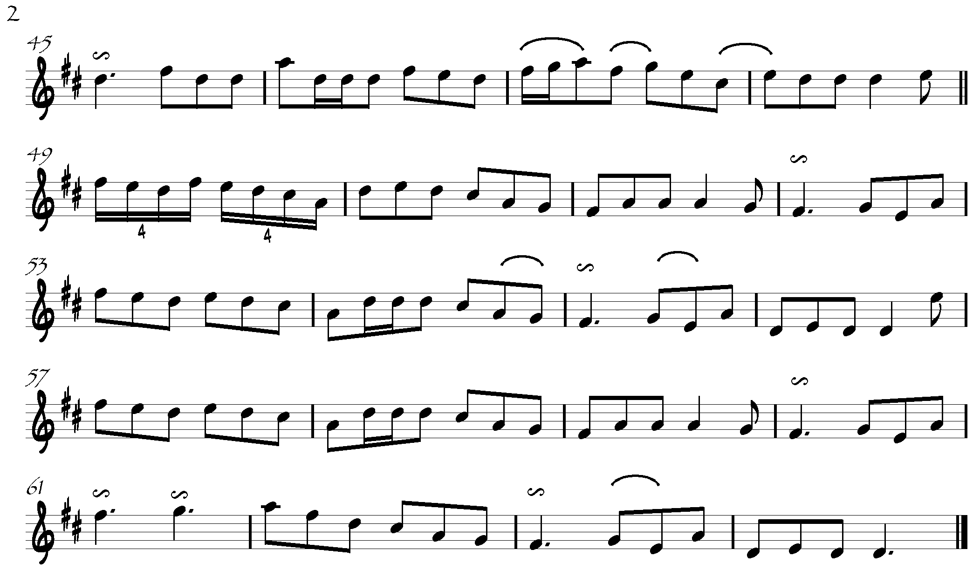

On other jigs, like Gillan’s Apples and The Rambling Pitchfork, he doesn’t use the quadruplet device, but still plays with great verve and fluency.

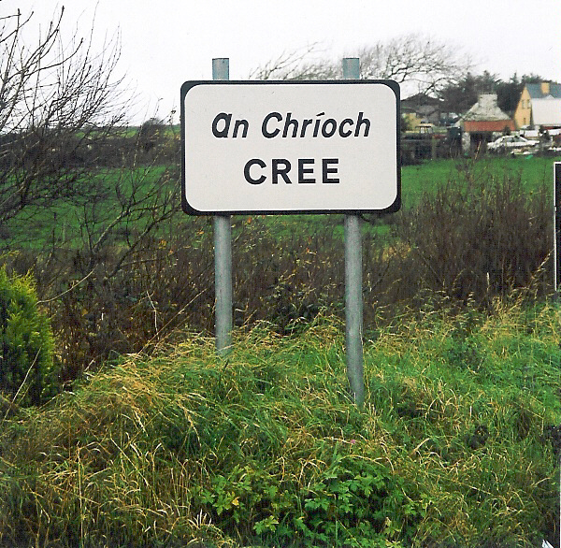
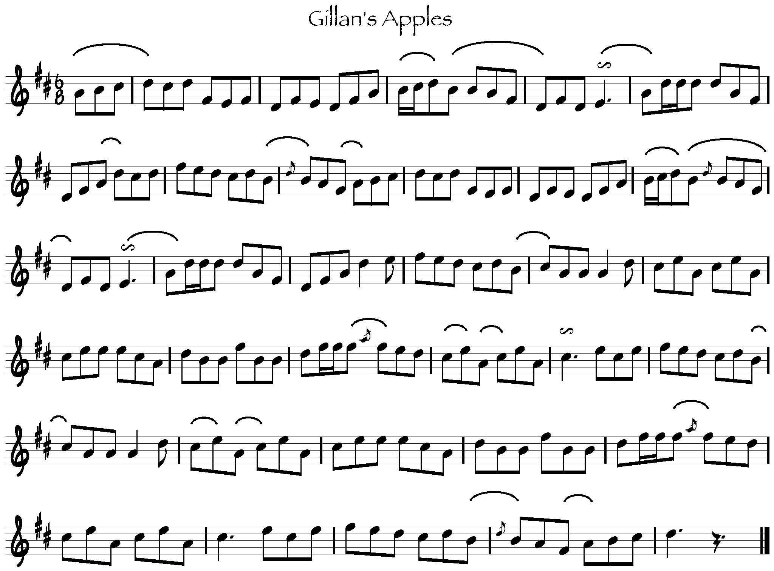
Small in proportion but significant in Patrick’s repertoire, in the context of West Clare, are a number of slides. Since slides have a strong connection with the repertoire of Sliabh Luachra and Kerry in general, my initial assumption was that the slides came to Patrick through the legacy of George Whelan, but there is no evidence on the origins of the tune. Batt Scanlon, another pupil of Whelan’s, published a manuscript in San Francisco in 1923 titled Violin Playing Made Easy and Attractive, containing a tutorial and tunes that Scanlon got from Whelan. That manuscript is extremely rare and I have been unable to view a copy, but have it from personal conversation with Matt Cranitch, who does have a copy of the manuscript, that the slides in Patrick’s repertoire do not appear in the book. The first slide below, Mickey Callaghan’s, is from an unpublished recording of Patrick in Séamus Mac Mathúna’s collection, and also appears in the repertoire of John Kelly, Sr. of Loophead and Micho Russell of Doolin. The second slide is the version played in Sliabh Luachra, for which I have no title.
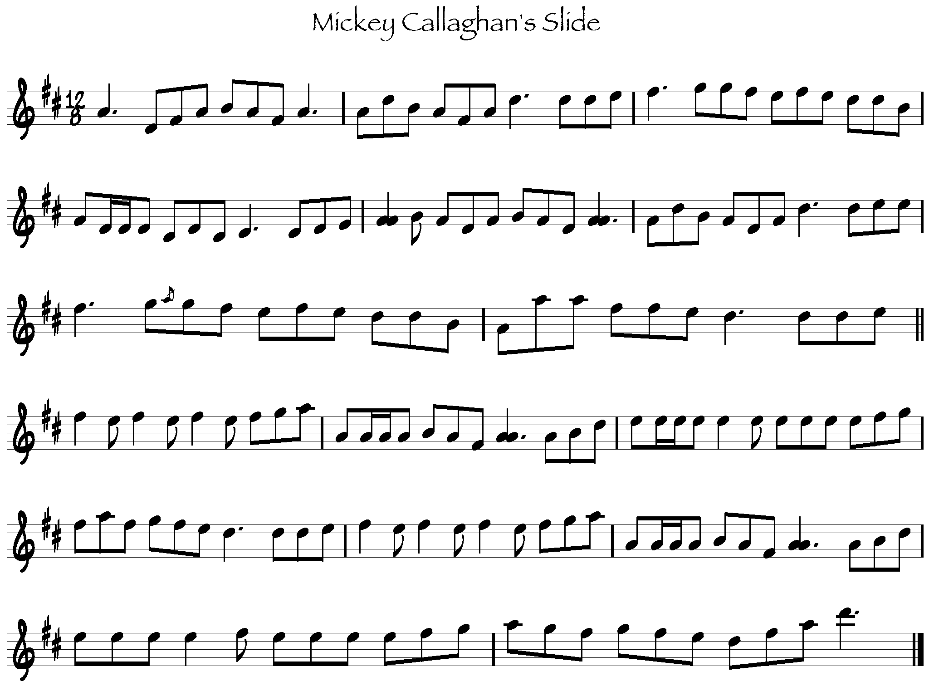
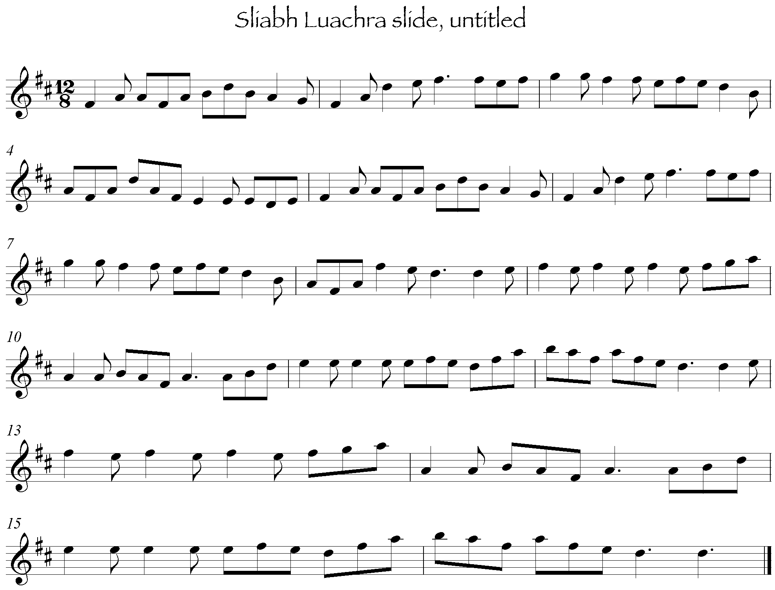
One link in the puzzle is Scattery Island, in the mouth of the Shannon. Purchased from the Limerick Harbour authorities at the beginning of the 19th century by a group of Kilbaha families, John Kelly’s grandmother, Mary Brennan, lived on Scattery. John Kelly went to Scattery Island as a young man and was impressed with the joie de vivre of the islanders, finding them a, “lively, witty people with a great passion for music, singing, and dancing.” The bulk of the islanders made their lives on the sea and so had a lot of music from encounters with other sailors, including a number of Norwegian tunes. John Kelly was surprised, on his early visits, that there were a greater number of waltzes on the island than there were on the mainland. Most important, in respect to the puzzle of the slides, is the link between Scattery Island and the music of Kerry.
My grandmother had a lot of tunes that weren’t known in county Clare, polkas, slides, and single jigs. She told me that when she was a girl, boatloads of people from Kerry would put in to the island almost every Sunday in summer. Then there was a dance in the lighthouse. In this way the Scattery people picked up the Kerry music. From my grandfather and grandmother I learned quite a number of Kerry style tunes…later when I got to know Willie Clancy I played these tunes for him. He had never heard of them in his part of the county.

Whelan is reputed to have only traveled in the area of Cree, Cooraclare, Kilmihil and Doonbeg: but the ferry at Tarbert was well-used and one imagines that there were a number of musicians crossing back and forth across the Shannon, with musical influence moving in both directions. A more curious question is the role that the slides played in Patrick’s repertoire. In general, most of the music in the locality was that played for dances: dancing in Cree would have mostly been the Plain Set, with the Caledonian Set coming on in later years. Both sets were danced to reels or polkas, depending on the version, for the majority of the figures, with a jig figure in the middle and a hornpipe figure at the end. Possibly the slides were played for the jig figures, though both Patrick and John Kelly make a distinction in the classification of their repertoire between slides and other kinds of jigs. Or they were listening pieces, played in respect of the men who handed them down: Tim Kelly, Denny Mescall, and George Whelan. A second slide in Patrick’s repertoire is Denny Mescall’s as played on Ceol an Chlair. This is a stronger link to Whelan’s repertoire than the first slide: Patrick said of Denny that, “every tune he got was from George Whelan, every tune he was able to play was from George Whelan and I don’t believe that he ever altered a note.” Denis Murphy played a similar version, transcribed by Breathnach, called Nelly O’Mahony’s. In conversation with Matt Cranitch, he remarked that, “this tune is in circulation in the present-day Sliabh Luachra tradition, and is generally known as If I had a Wife, although Pádraig [O Keefe] played a different tune with this same title.”
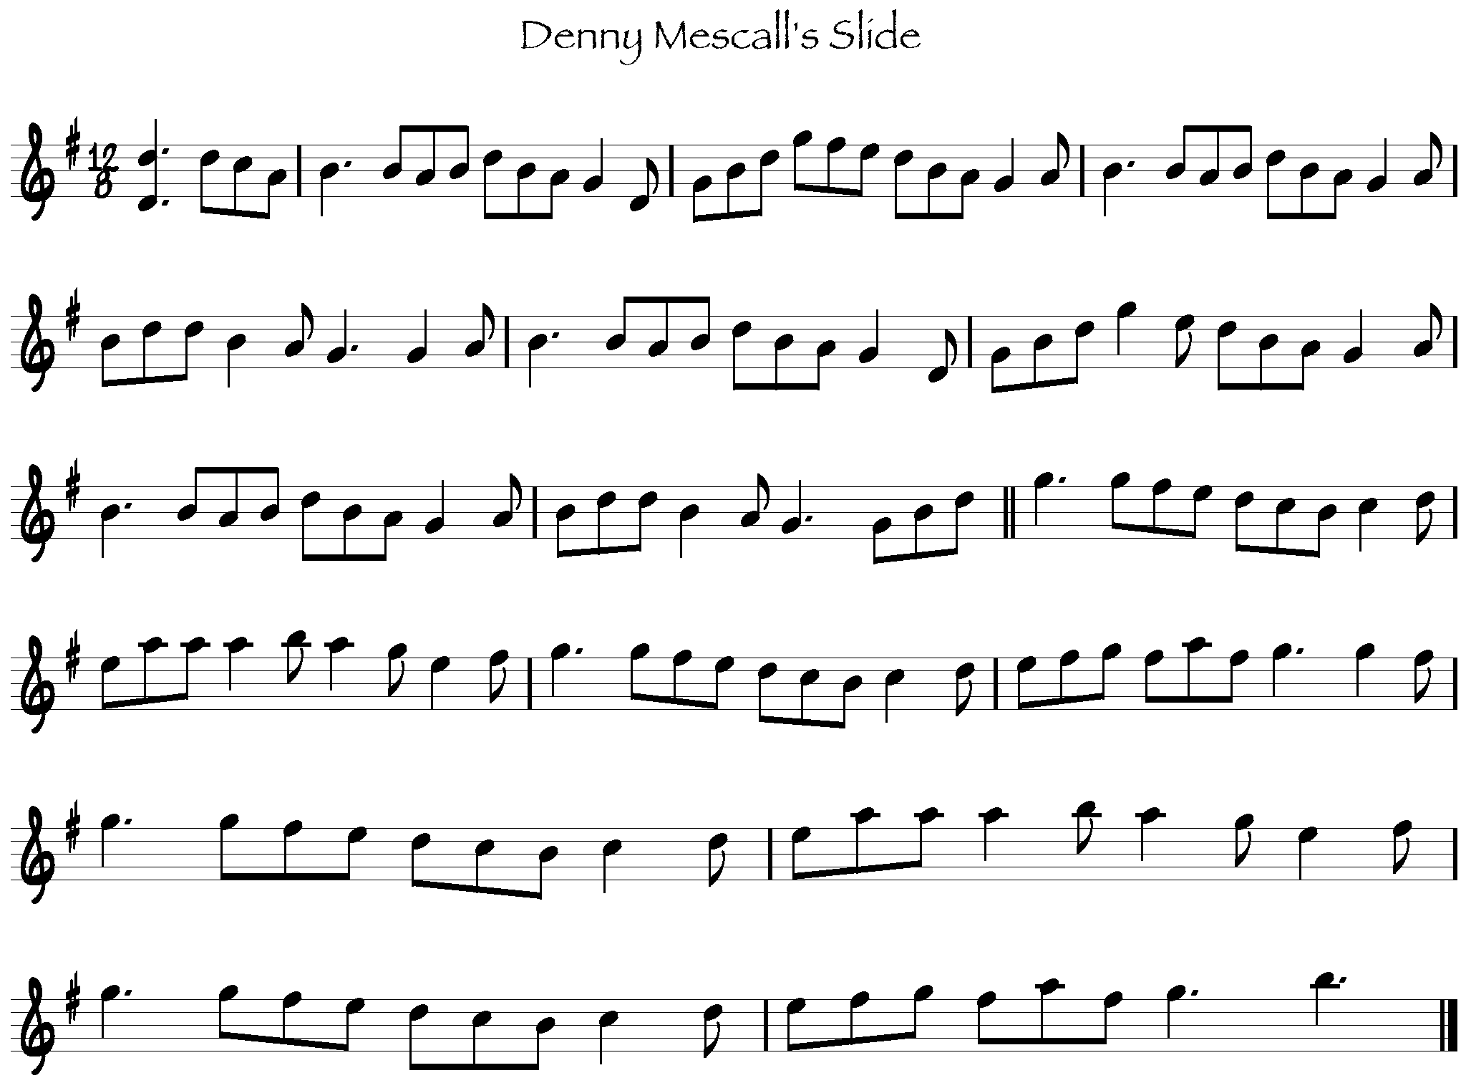

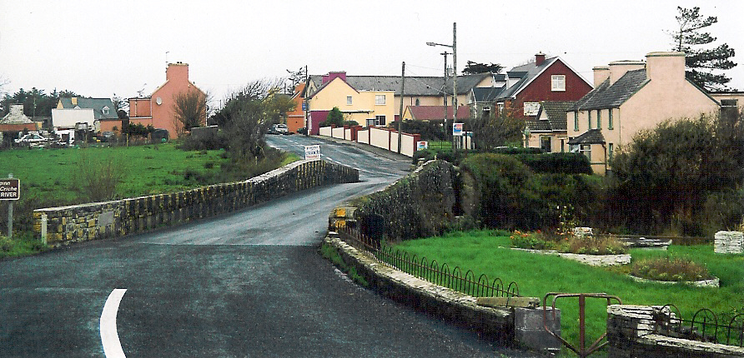
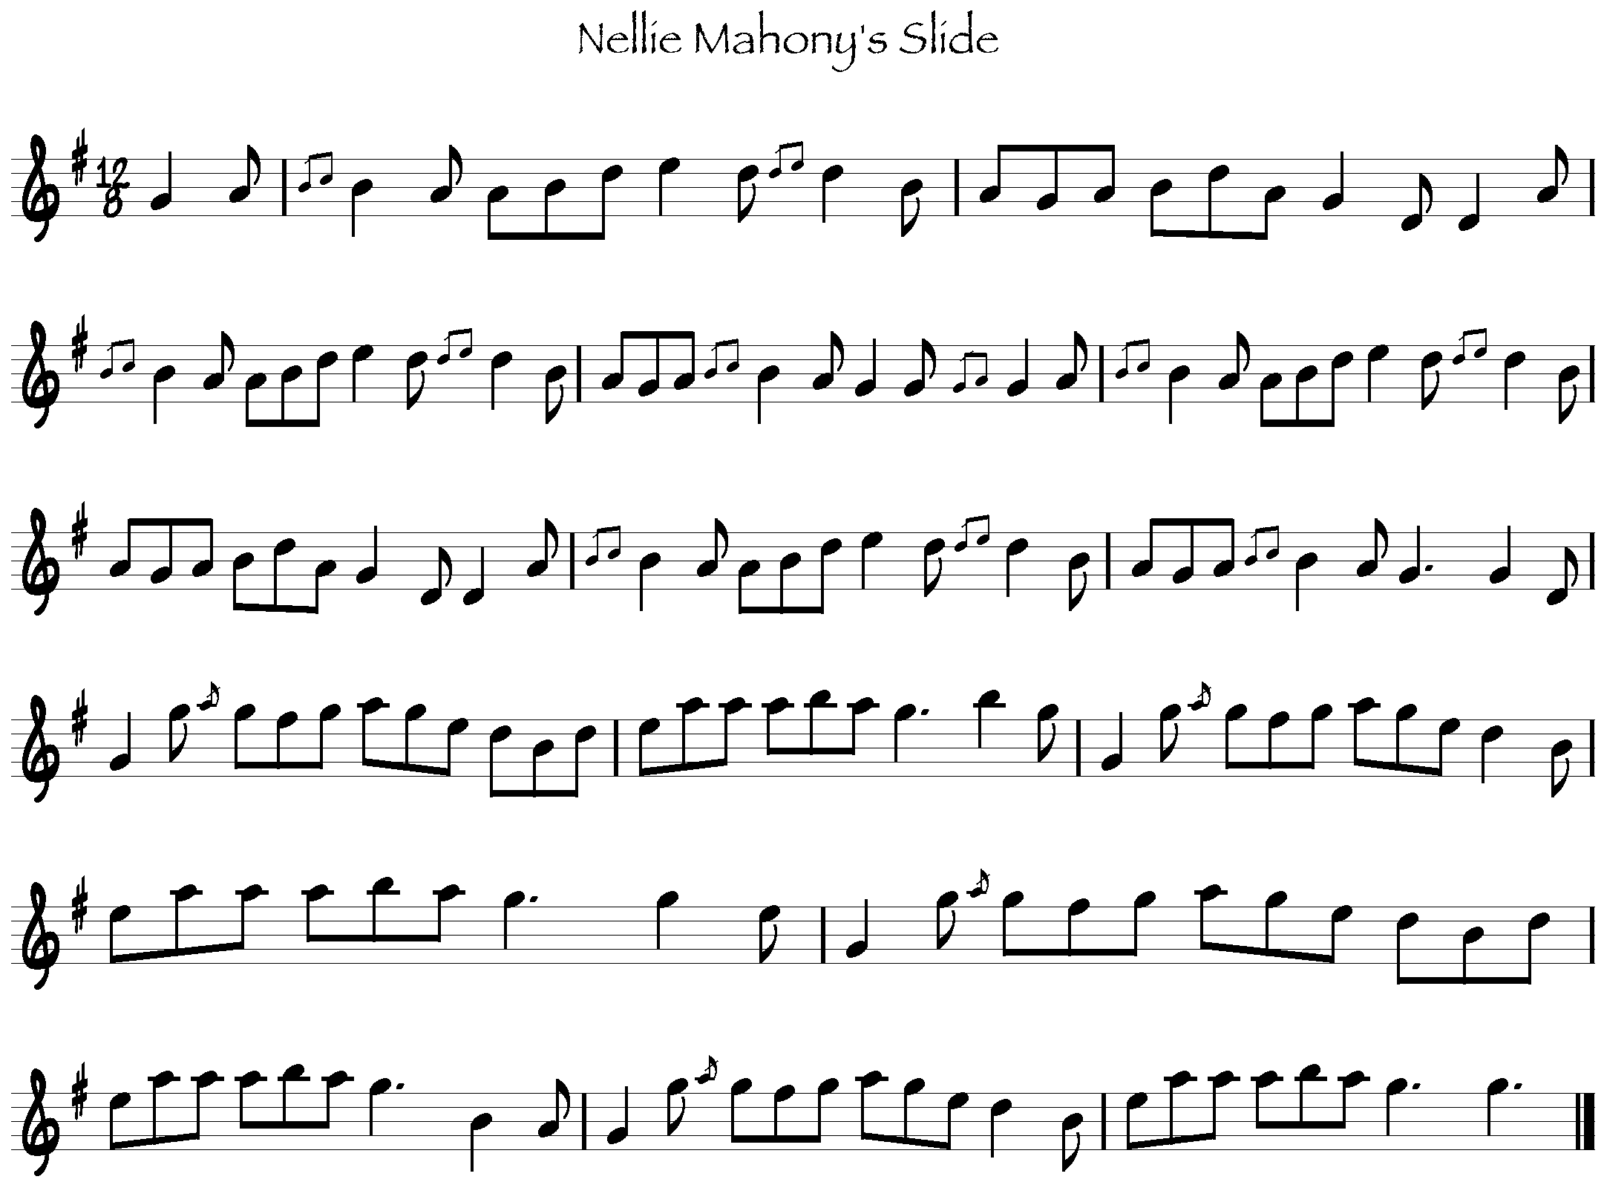

Patrick also played a number of set dances: The Blackbird, Humours of Bandon, Job of Journeywork, Ace and Deuce of Pipering, The Priest in his Boots, An Suisin Ban, and Rodney’s Glory are all in O’Neill’s. Patrick’s settings, though different in small particulars, stay fairly close to those in ‘the book’. He mentions several of these as being handed down from his father: given their presence in O’Neill’s one can assume they had a fairly large distribution. A set dance seemingly unique to Patrick’s repertoire is O’Connell’s Farewell to Dublin. Patrick recalled getting the tune off of Daniel Mack from Kilmihil, an old man when Patrick knew him, who, “had a wonderful collection of music.”

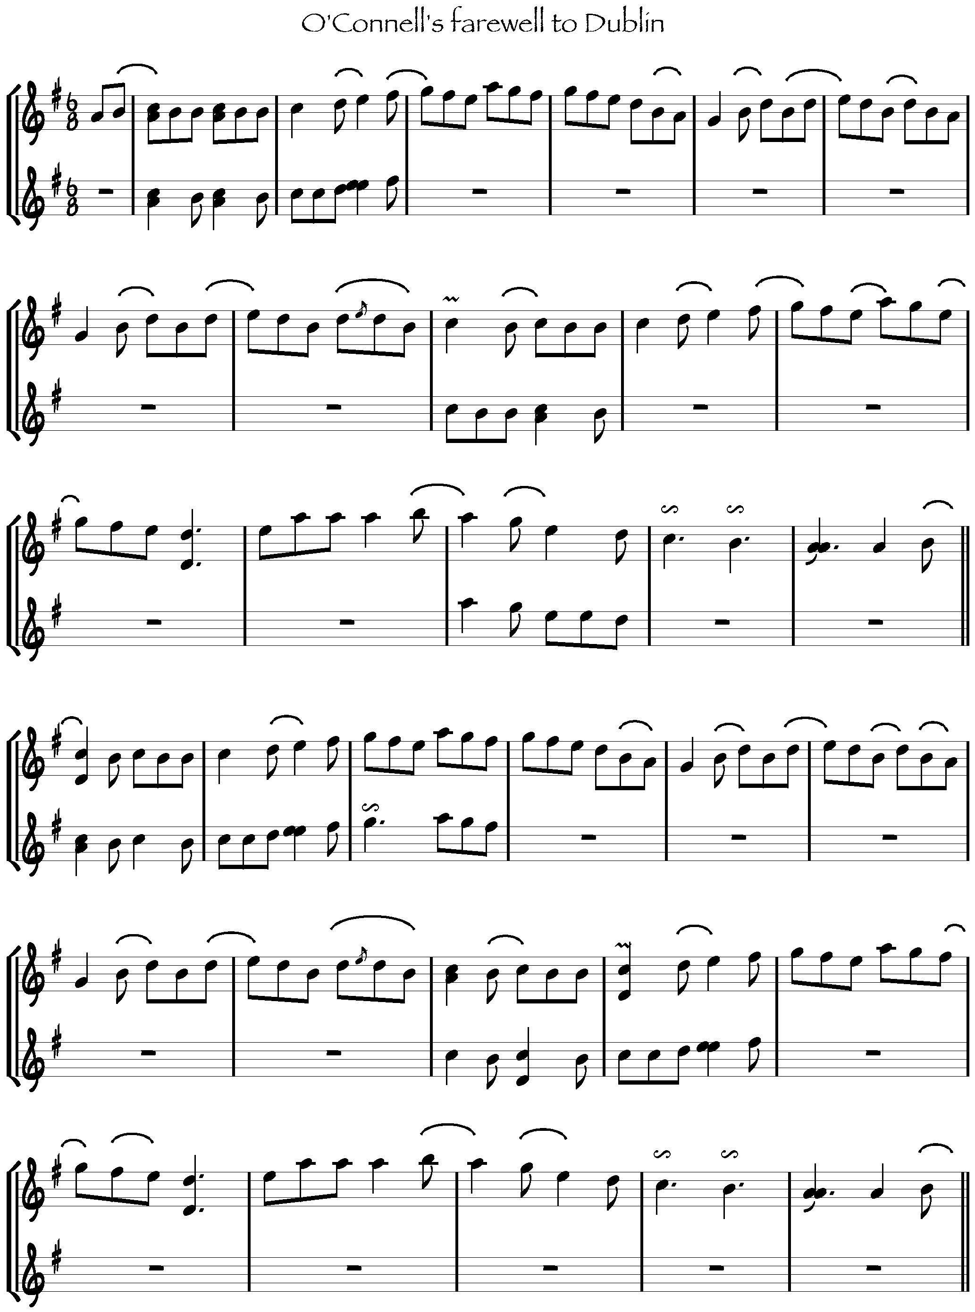
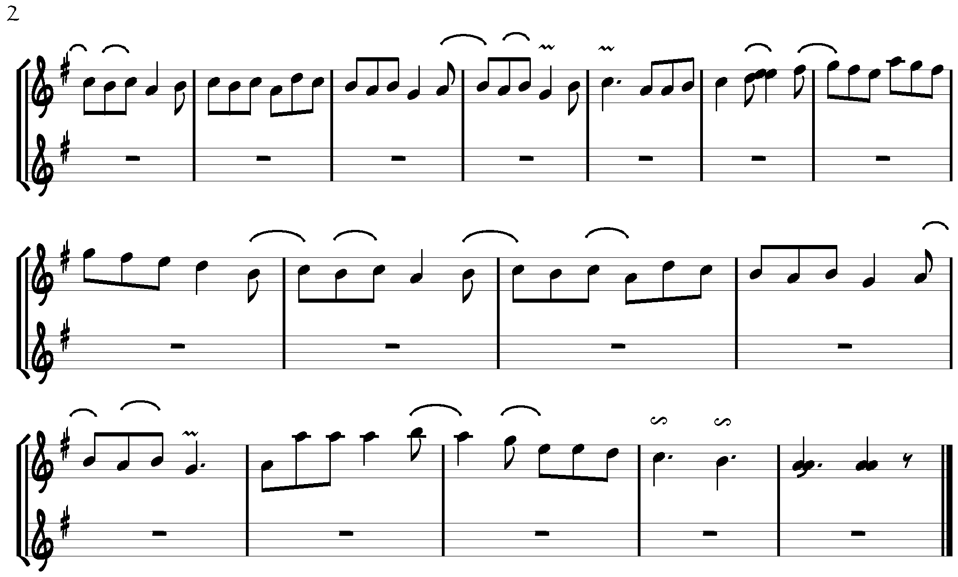

While Patrick’s settings are highly personal and creative, there is little variation in his playing. Once he arrived at a satisfying version of a tune, it seems to have remained fairly static. This is true both through the playing of a tune—in The Frieze Britches the quadruplet ornament is used the first time through the fifth part of the tune on each repetition—and across time—in the recordings done by Séamus Mac Mathúna and the home recordings recently put out by the family, recordings separated by at least a few years, Patrick’s playing of the Foxhunter’s is nearly identical. What variation does exist generally amounts to the interchangeability of two quavers for a crotchet on the same note, as can be seen in the transcription of O’Connell’s Farewell. The College Groves is one exception, with a certain amount of variation on the third repetition of the tune, particularly at the top of the B part, bars 9-11. In bars 9 and 10 rolls on the D and C are repeated, rather than following the roll with an arpeggio as seen in the earlier repetitions of the tune. Measure 11 is one of the few instances of substituting different melodic material, going up to the A from the F#, rather than down to the D.
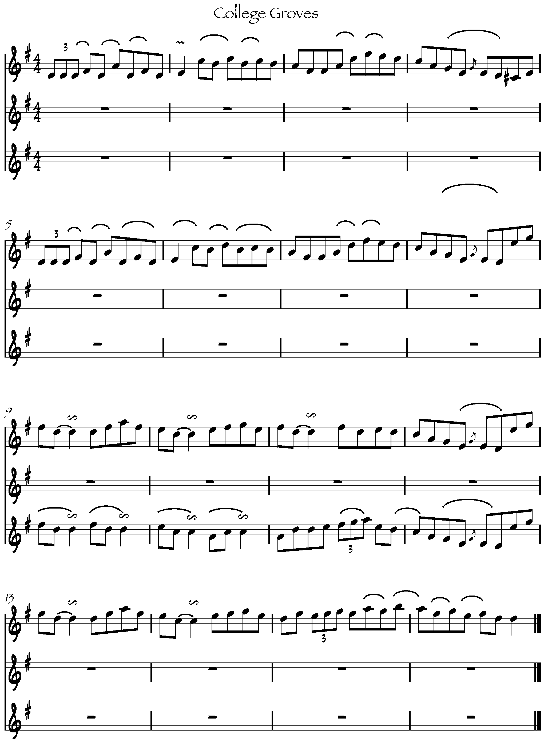

Hornpipes figure little in Patrick’s repertoire, with The Liverpool being the only recorded example. There is one waltz among the recordings, a piece called The Dew Drop that comes from the home recordings. Completely different in effect from the other tunes, it features an extensive use of vibrato and has a continental feel.

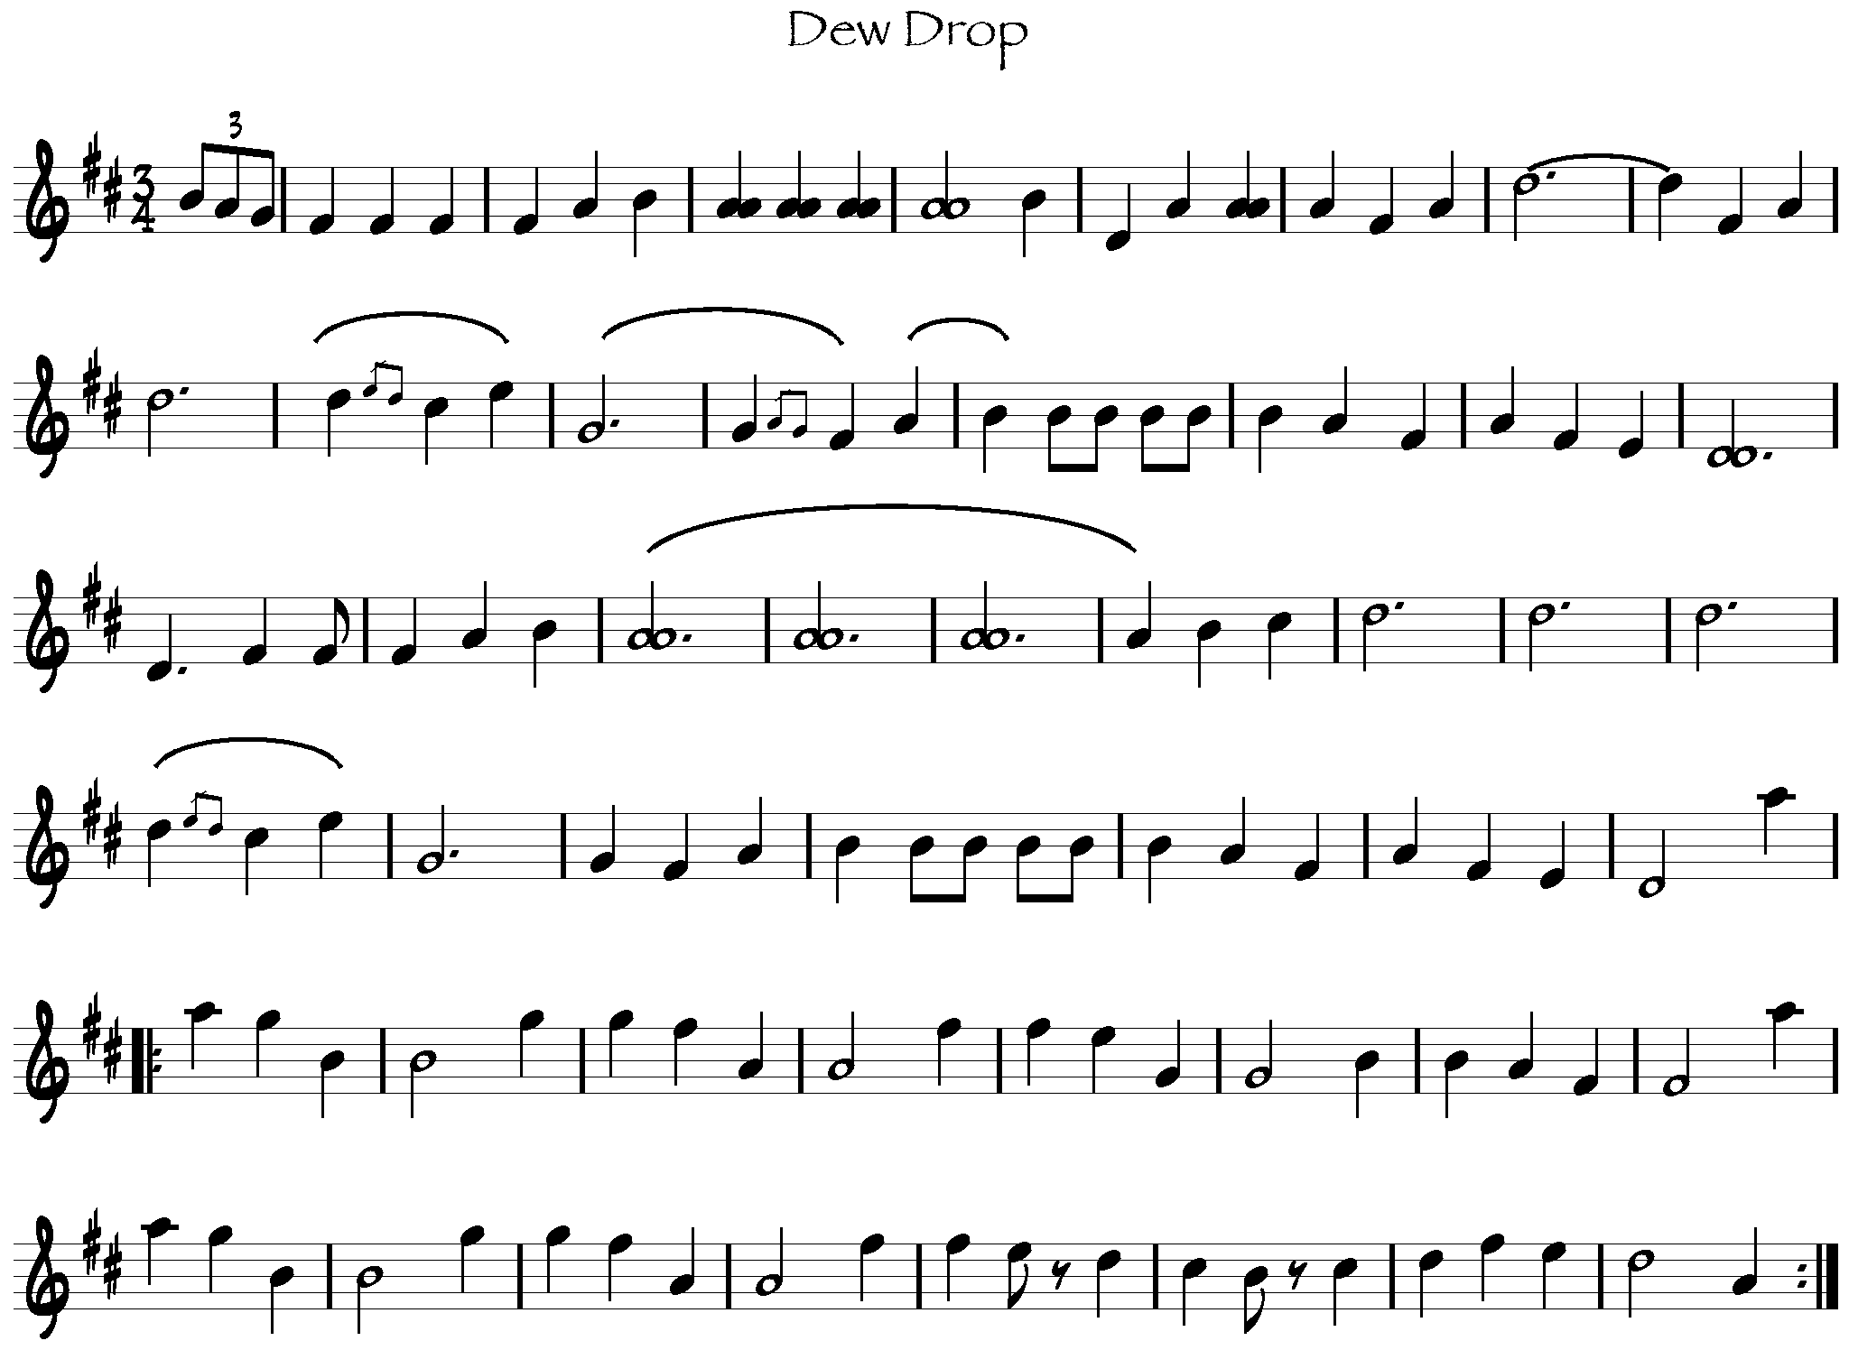

Style

The four main styles generally recognized are those of Donegal, Sligo, Clare and Sliabh Luachra: descriptions of both Clare and Sliabh Luachra are relevant in considering Patrick Kelly’s playing. The excerpts below are from Fintan Vallely’s The Companion to Irish Traditional Music.
Clare: The slower tempo of the Clare style allows the player to concentrate more on the melodic aspects of the music. The bowing is more fluid, and extensive use is made of left-hand ornamentation such as rolls. Frequently a distinction is made between the music from the west of the region and that from the east. The West Clare style is well represented by the playing of Bobby Casey, Junior Crehan, John Kelly, Patrick Kelly and Joe Ryan.

Sliabh Luachra: On the Cork/ Kerry border near the source of the river Blackwater, Sliabh Luachra is renowned for slides and polkas. The direct and rhythmic style of playing these has influenced the playing of the other dance tunes. As the music is frequently played for the dancing of sets, it is lively and exuberant. Ornamentation is achieved mainly with the left hand, while the bow-hand provides the characteristic rhythm. A particular feature is the use of open strings to provide a drone-type rhythmic effect.

Patrick Kelly’s playing shows characteristics of both the West Clare style, as one would expect, and of a Kerry influence, if not the Sliabh Luachra style per se. For the purposes of discussion I will consider the hallmarks of a North Kerry style as being similar to the description of Sliabh Luachra music above. George Whelan’s influence has been noted, and likely accounts for the presence of slides, the use of drones, and the rhythmic approach to jigs in Patrick’s playing. Within the West Clare style, Patrick drew a distinction between his region and the Miltown area.
Would you say there’s a difference in the music of West Clare from this side down and from Miltown up?

There is, mind you. There is a difference in the style of music, because Thady’s style and mine were completely different altogether. He had music from a great player up there, he called him O’Donnell, and O’Donnell had great music because Thady had great music. Everything he played was good.

Of the difference between the two West Clare styles, one presumes a greater Kerry influence in the Kilrush area, given the geographic proximity. Scattery Island and the presence of Whelan 1880 reinforce the theory. Given that boats went both ways across the Shannon, it is likely that a North Kerry style would have influences of Clare as well as Sliabh Luachra, creating a geographic continuum from Sliabh Luachra to North Kerry to Kilrush to Miltown. Critics of the concept of regional style argue that this redefinition of regions could continue ad infinitum until every parish and every house had its own brand of music, at which point it would become a meaningless distinction. While that argument holds some merit, and individual exceptions to regional style are numerous, the idea still helps us assess and understand someone’s playing. Patrick Kelly was a creative and unique fiddler, but looking at what he did with the tunes in the context of the music that was being played around him allows us to see his individual genius all the more clearly. And I think it’s a lovely thing when the lines get muddied: Patrick stands as one of the defining players of the West Clare style, yet bears clear influences of Kerry. It is, after all, a small island.

In looking at an individual approach to music, I would posit that there are four main aspects of fiddle playing that define a player’s style: bowing, ornamentation, intonation and tempo. Bowing includes not only the direction of the bow and choice of slurring, but also the quality of attack and other considerations employed to produce desired tone quality; ornamentation includes rolls, trebles, cuts, slides and squawks; intonation the choice of tuning on certain fluid notes, particularly the F and C, and the tuning of the fiddle; and tempo the speed at which the tunes are executed.

Intonation

All recorded examples of Patrick’s playing are below concert pitch, ranging anywhere from a half step to slightly more than a whole step below A440. The fiddle is particularly warm and resonant at such a low pitch, and the use of drones and double-stops particularly effective. Of the fiddlers also named as being representative of the West Clare style, Bobby Casey and Junior Crehan also tuned down, while Joe Ryan and John Kelly played at concert pitch. Patrick’s choice of intonation was fluid, particularly with the C natural/ super-natural sounded by the second finger on the A string. In O’Connell’s Farewell to Dublin, Patrick uses a wide range of color on the prominent Cs in the melody, giving the tune much of its expressiveness and draoicht.
This motif is repeated throughout the tune, and is treated in a number of ways, with the moveable C being droned against an A played by the fourth finger, against the open D, and decorated with rolls or “squawks”. The C is treated in a similarly fluid manner in The College Groves and The Frieze Britches, among other tunes. Fs tend to be the next note treated with fluidity: I came across no examples of tunes with a true F natural, but Patrick does play his F# a touch flat. Indeed, most major thirds are played flat, another characteristic of a West Clare “sound”. These characteristics were shared by Casey and Crehan, but are found as well in the playing of Denis Murphy, continuing to muddy the line between Clare and Kerry. “The Waiver” also tuned his fiddle low by a half-step, with a fluid treatment of C’s and F’s, and a resonant wildness in his playing. Patrick frequently used his fourth finger to sound a unison drone against open strings, often sliding the fourth finger up from a flattened position to emphasize the note. As often, the fourth finger would remain a touch flat, creating a resonant dissonance. Examples are from The Frieze Britches, on the E, and O’Connell’s farewell, with the slide very prominent on the ending note of the phrase.

Tempo

Patrick played reels between 96 and 100 bpm: a relaxed, Clare tempo and very close to Bobby Casey and Joe Ryan. Denis Murphy, by contrast, played Kennedy’s Favourite at the healthy clip of 118 bpm on the Kerry Fiddles album. Patrick played jigs a bit faster than his reels, with Gillan’s Apples at 110 bpm and Banish Misfortune at 108. This is a touch faster than Casey’s rendition of The Gallowglass at 104. Denny Mescall’s and Mickey Callaghan’s slides are both played by Patrick around 114 bpm: comparable to Denis Murphy’s playing of Rathawaun and Chase Me Charlie, but considerably slower than prevailing trends in Sliabh Luachra. In Johnny O’Leary of Sliabh Luachra, Terry Moylan notes that many of Johnny’s slide tempos are between 150 and 160. . Patrick’s approach to the slides, and the Clare approach generally, would be somewhat different from how they are played in Sliabh Luachra. This from Matt Cranitch:

In Sliabh Luachra, slides are played with more of a rhythmic emphasis and urgency, due no doubt to the influence of the set-dancing. Also, they appear to be played a bit faster. Over the years from listening to Clare musicians, and even more recently to people like Michael Tubridy, I am reinforced in my opinion that they approach these tunes somewhat differently.

Patrick was aware that the older players tended to play more slowly, and recalled that Denny Mescall lost popularity with the dancers because he played too slow. “Denny was kind of chased out of the house dances, because Denny played the old music slow, and this set dancing had come in with the gramophones.”

Ornamentation

More ornate than Mrs. Crotty’s spare playing, less adorned than someone like Bobby Casey, Patrick had a wide range of ornaments at his command: rolls, trebles, cuts, double-stops, slides, squawks, and quadruplets. Of these, the use of double-stops to create added resonance, slides to emphasize prominent notes, and squawks to create wildness are the most emblematic aspects of his playing. When double-stopping the added tone, invariably lower than the melody note, is not bowed for the full duration of the melody note. Patrick taps these notes with his bow, lifting off of them while continuing to sound the melody, in a way that allows the fiddle to resonate. Sliding into a fourth finger unison drone is a common feature of Patrick’s playing, again with the drone not lasting the full duration and with the fourth finger often being slightly flat and dissonant to the open string. By squawks, there are times when Patrick would seem to make the fiddle bark with a combination of increased bow pressure and shifting of the fingered note. O’Connell’s Farewell is a good example of these techniques, with the G and C notes in bars 2 and 3 being ‘squawked’, and the E an example of a sliding double stop with the fourth finger.
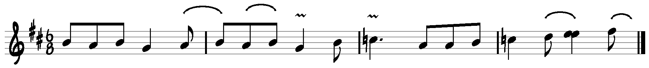

Patrick’s use of quadruplets in jig time has been noted above, and was a spectacular feature of his settings of Banish Misfortune and The Frieze Britches. In both tunes the notes of the ornament are the same, and are bowed in a sharp, staccato fashion. The first bar of the following example is the ornament as played by Patrick; the second shows the standard melody that it replaces.

In addition to the quadruplet figure, Patrick used trebles extensively in his jig playing, usually doubling the second quaver of the group, as in this example from The Frieze Britches.

Patrick used rolls relatively sparingly; when he does his rolls are a very rhythmic device, giving the impression of three separated notes, almost like a treble. The fingering of the ornament is the same as the standard: a fingered note graced above with a cut, lifted and put back down. But where other players may treat a roll melodically, allowing you to hear the five distinct notes of the ornament, Patrick’s are rhythmic, with the ‘flick’ and the ‘hop’ not sounding melodically, just interrupting the flow of the melody note. In certain instances, as with The Foxhunter’s, the final note of the roll is replaced by the open string, for a distinctive effect.
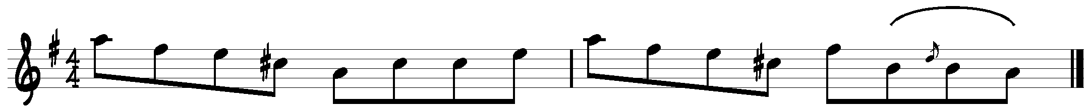
Cuts are used frequently to separate two notes of the same value, as in bars 7 and 8 of Gillan’s Apples.
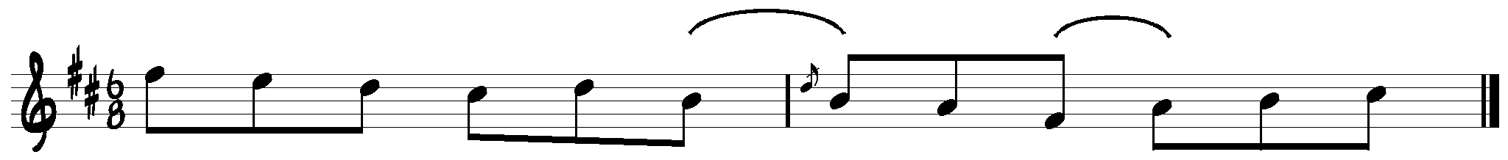

Bowing

In Gillan’s Apples Patrick demonstrates not only the effectiveness of alternating between separate and slurred bowings, but in alternating the attack and pressure of the bow to create different sounds. At the beginning of the A part, Patrick plays with short, choppy strokes, likely executed near the frog to achieve a punchy, rhythmic sound. In the turn of the tune, Patrick uses a smoother bow attack and a slurring pattern that contrasts strongly with the opening approach to the tune.
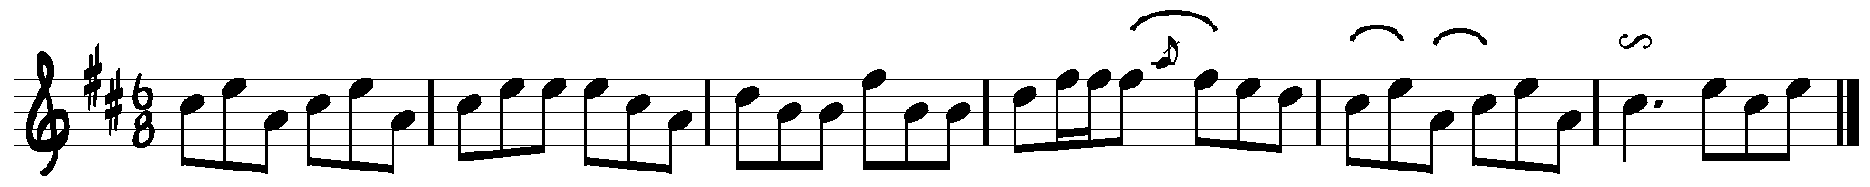
The wide palette of tone color is heard throughout Patrick’s playing; also characteristic from the above example is the placement of a slur across a beat. According to Caoimhin O Raghallaigh, slurring across the beat is the “essence of all Munster fiddle playing,” and is compensated for by applying extra bow pressure at the beat, a “wah” to create subtle emphasis. The opening bars of The College Groves show Patrick slurring across the beat.
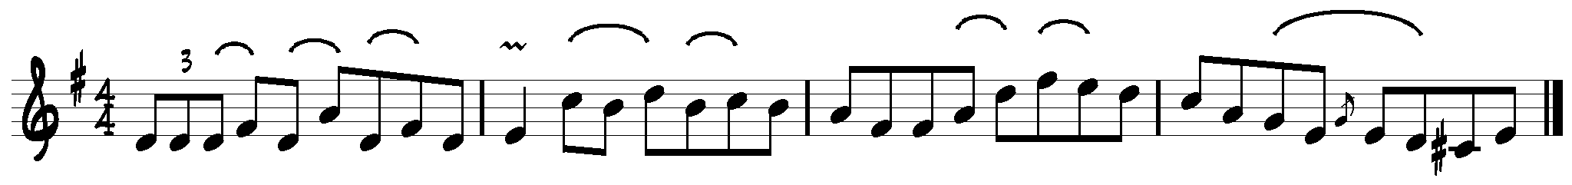
Such slurs are frequent throughout Patrick’s playing, accounting for much of the swing.

Other

Patrick preferred to play tunes singly: “He hardly ever followed in to a second tune. He nearly always stopped after playing the one tune.” The only published exception to this is the medley of The Salamanca and The Milliner’s on Ceol an Chlair: interestingly, on some private tapes loaned me by Séamus Mac Mathúna Patrick follows another reel in D, unidentified, with The Milliner’s Daughter. On the same tapes, Patrick pairs The Sporting Pitchfork and The Rambling Pitchfork. Outside of these, all of the tunes are played singly, which seems to have been the standard in the locality. Again, this has connections to the aesthetic of dance playing, where musicians would play one tune per figure. Mrs. Crotty, strongly rooted in dance playing, also played the great majority of the tunes singly. Tom Kelly reckons the influence of Martin O’Dea, the priest who preserved the home recordings of Patrick, led Mrs. Crotty to create the medleys she did.
Now this fellow Martin O’Dea that I was telling you about. He brought Mrs. Crotty to Dublin to make her first record, the 78 with The Reel with the Birl and The wind that shakes the Barley. But you see as it was with all the old musicians, and as it was with my father on that tape there, they all played single tunes. But he had her told, you’re to play two tunes after one another without a stop. Father Martin had her told, and she started after leaving here, practicing, and they were in the Curragh of Kildare when she got it. I often heard him telling that.

One of Patrick’s most striking pieces was The Foxhunter’s, played with the fiddle tuned EAEA, from highest string to lowest. Though cross-tuning is common in other fiddle traditions, particularly those of Scotland, French-Canada and the Appalachians, it seems to be an anomaly in the Irish tradition. Changing the tuning of the strings makes the fiddle particularly resonant and full, something that Patrick’s setting of the tune uses to great effect in the second part of the tune, bars 9-16. The opening E of that phrase is sounded by the open string, not the first finger as in standard tuning, and continues to ring while the notes are fingered on the A string. Of the transcriptions below, the first is notated by pitch while the second is notated as fingered that fiddler may see where open strings come into play. A hallmark of cross-tuning where it appears in other traditions, particularly in American old-timey (Appalachian) playing, is putting the high part of a melody an octave lower, where it’s growly and driving. It’s an easy device, as the fingering is exactly the same on the lower two strings as on the higher: the third, fourth and fifth parts of the tune are perfectly suited, as the melody remains on the two high strings. Usually this would happen a number of repetitions into the tune to give it new lift. But it’s a facet of the tuning that Patrick doesn’t explore: indeed, only 12 bars of the 40 use the third string at all, and the lowest string remains untouched. Even without using the lower strings in the melody, changing the tuning of the fiddle has a huge impact on the resonance of the instrument and the nature of the tune. As with the slides, we can only surmise as to the origins of The Foxhunter’s and the use of cross-tuning. Patrick had the tune from his father Tim, which suggests that it has its roots in the Kerry of George Whelan.

The Foxhunter he wouldn’t play that often. He could play several sessions and he’d never play The Foxhunter, because he always tuned the fiddle up to do it. So, except at the end of night and someone would ask him to play The Foxhunter and then he might play a couple of tunes after with the fiddle still tuned the same, the same tuning.

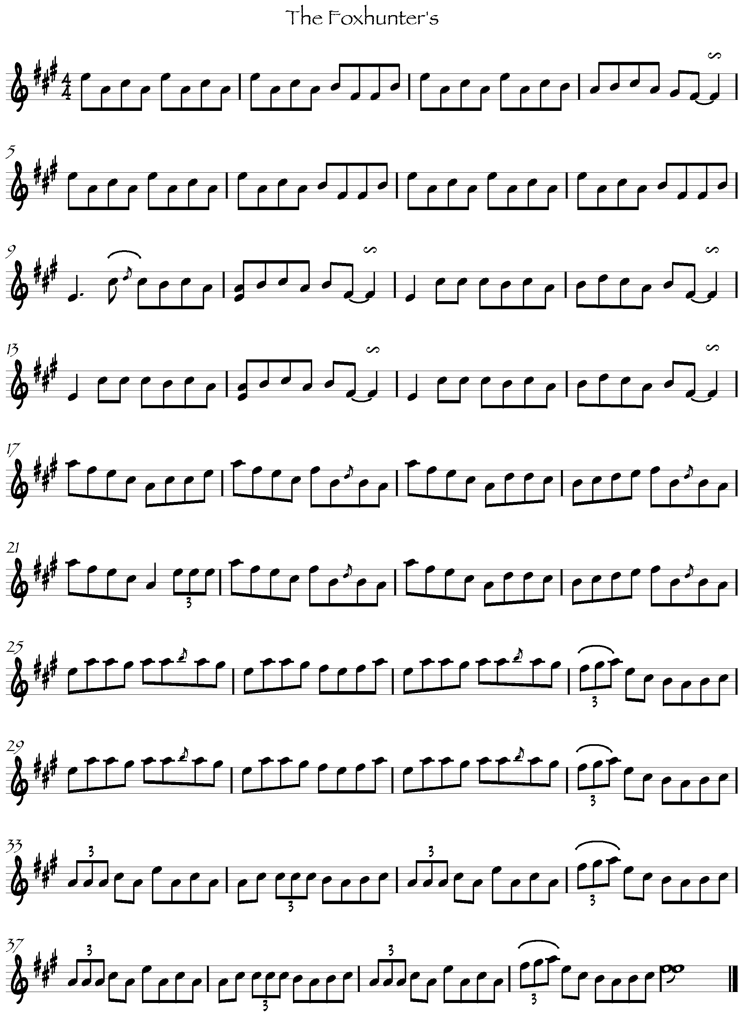
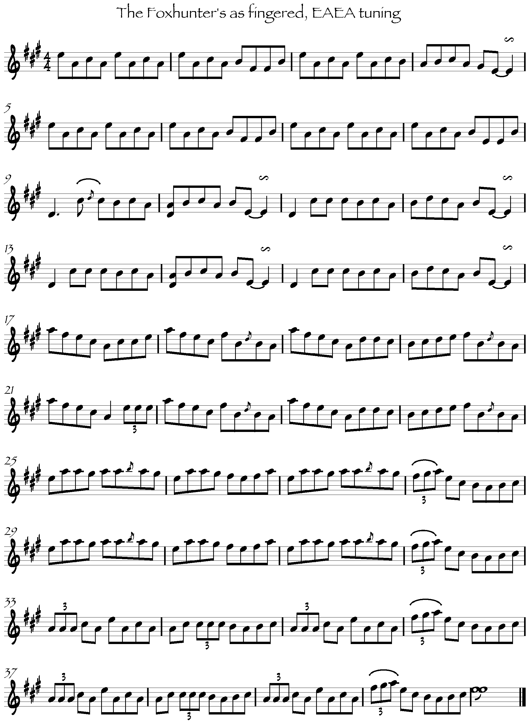

Conclusion

Every time I listen to it I always think that you could have a good 20 years work just listening to that hour or whatever it is of Patrick Kelly. It’s pretty much a lifetime study; you listen to it and you get a certain level of appreciation for it. You come back a month later and you hear a whole new side of things, and you come back a year later and you realize you haven’t heard it at all. It’s music of infinite depth. That old music of great quality, you keep going back to it.

Ne’er a truer word was spoken. In the course of this research I have been immersed in the music and the world of Patrick Kelly, yet every time I listen to him anew there’s something I hadn’t caught before. It is lovely stuff, this making aeroplanes out of scrapheaps.
Bibliography

Breathnach, Breandán. Folk Music and Dances of Ireland, The Talbot Press, Dublin, 1971. (1996, Ossian Publications, Cork)

Breathnach, Breandán. Ceol Rince na hÉireann, Vol. 2,
An Gúm, Dublin, 1976.

Breathnach, Breandán. Ceol Rince na hÉireann, Vol. 3,
An Gúm, Dublin, 1985.

Lynch, Larry. Set Dances of Ireland: Tradition and Evolution,
Séadna Books, San Francisco, 1989.

Lyth, David. Bowing Styles in Irish Fiddle Playing, Vol. 2,
Comhaltas Ceoltóirí Éireann, Dublin, 1996.

Moylan, Terry, ed. Johnny O’Leary of Sliabh Luachra,
The Lilliput Press, Dublin, 1994.

O’Doherty, Eileen. ed. The Walking Polka: A Collection of Sets,
Na Píobairí Uillean, Dublin, 1995

Vallelly, Fintan, ed. The Companion to Irish Traditional Music,
Cork University Press, Cork, 1999.

Articles

Mac Mathúna, Séamus “Patrick Kelly of Cree”: Dal gCais, vol. 3

Mac Mathúna, Séamus “Patrick Kelly of Cree”: Treoir, vol. 6, 1974

O Cathain, Diarmuid “The Old Musicians of North Kerry”:
An Aisling:III, Comhlatas Ceoltoiri Eireann

Ó Rócháin, Muiris (? – uncredited, but Muiris is a likely author)
“The Life and Times of John Kelly”: Dal gCais 5,
1979
Ó Súilleabháin, Micheál “The Creative Process in Irish Traditional Dance
Music”

Taylor, Barry “Patrick Kelly of Cree, Co. Clare”: Slow Air, 1977.

Interviews

Kelly, Patrick, 1972. Personal Interview with Michael O Connor.

Kelly, Patrick, 1966. Personal Interview with Séamus Mac Mathúna.

Kelly, Tom, Jim Kelly and Barry Taylor, 2004.
Personal Interview with Brendan Taaffe.

Mac Mathúna, Séamus, 2004 Personal Interview with Brendan Taaffe.

O Raghallaigh, Caoimhin, 2004 Personal Interview with Brendan Taaffe.

Discography

Ceol an Chlair, vol. 1. Comhaltas, 1979.

Elizabeth Crotty: Concertina Music from West Clare. RTÉ 225CD, 1999.

Patrick Kelly from Cree: Fiddle Music. PKFC 001, 2004.

Mick O’Brien agus Caoimhin O Raghallaigh: Kitty Lie Over. ACM CD 102, 2003.

Appendices

Appendix 1: transcriptions of tunes from Patrick Kelly’s repertoire

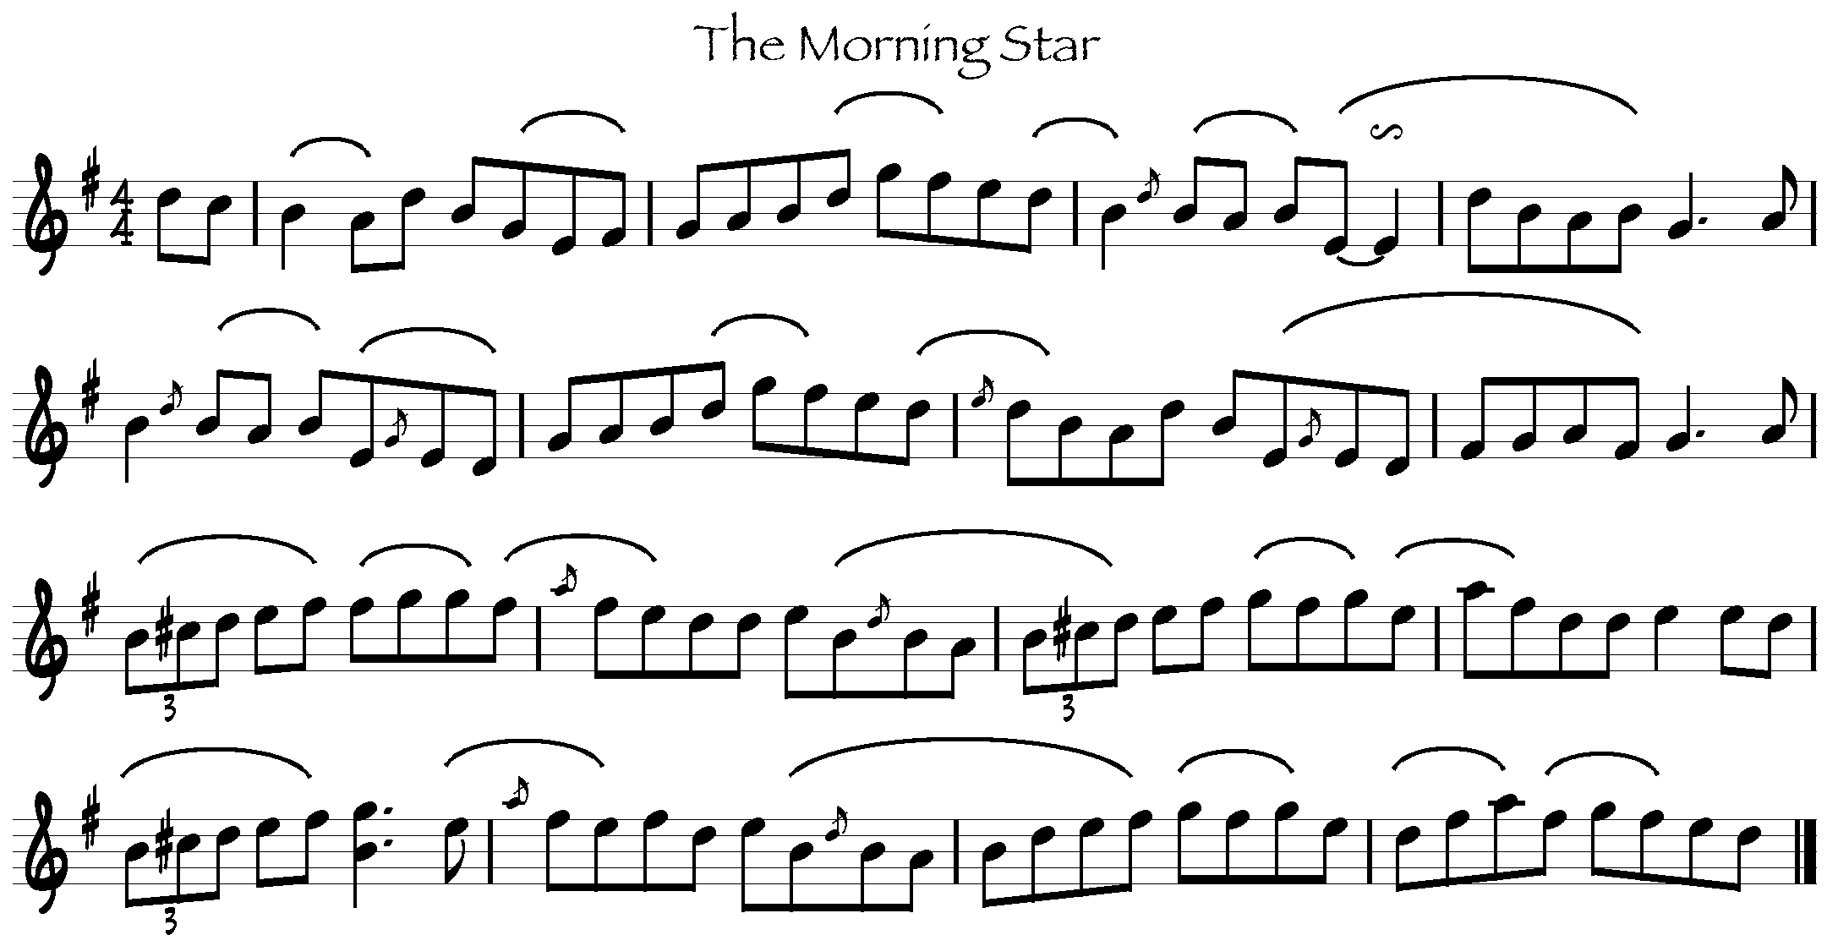
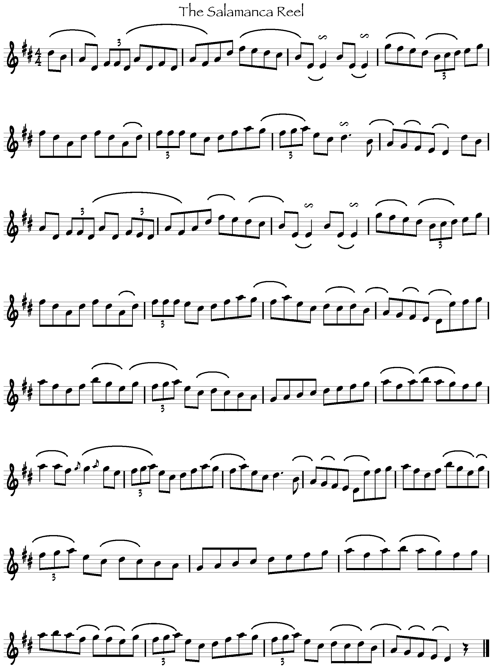
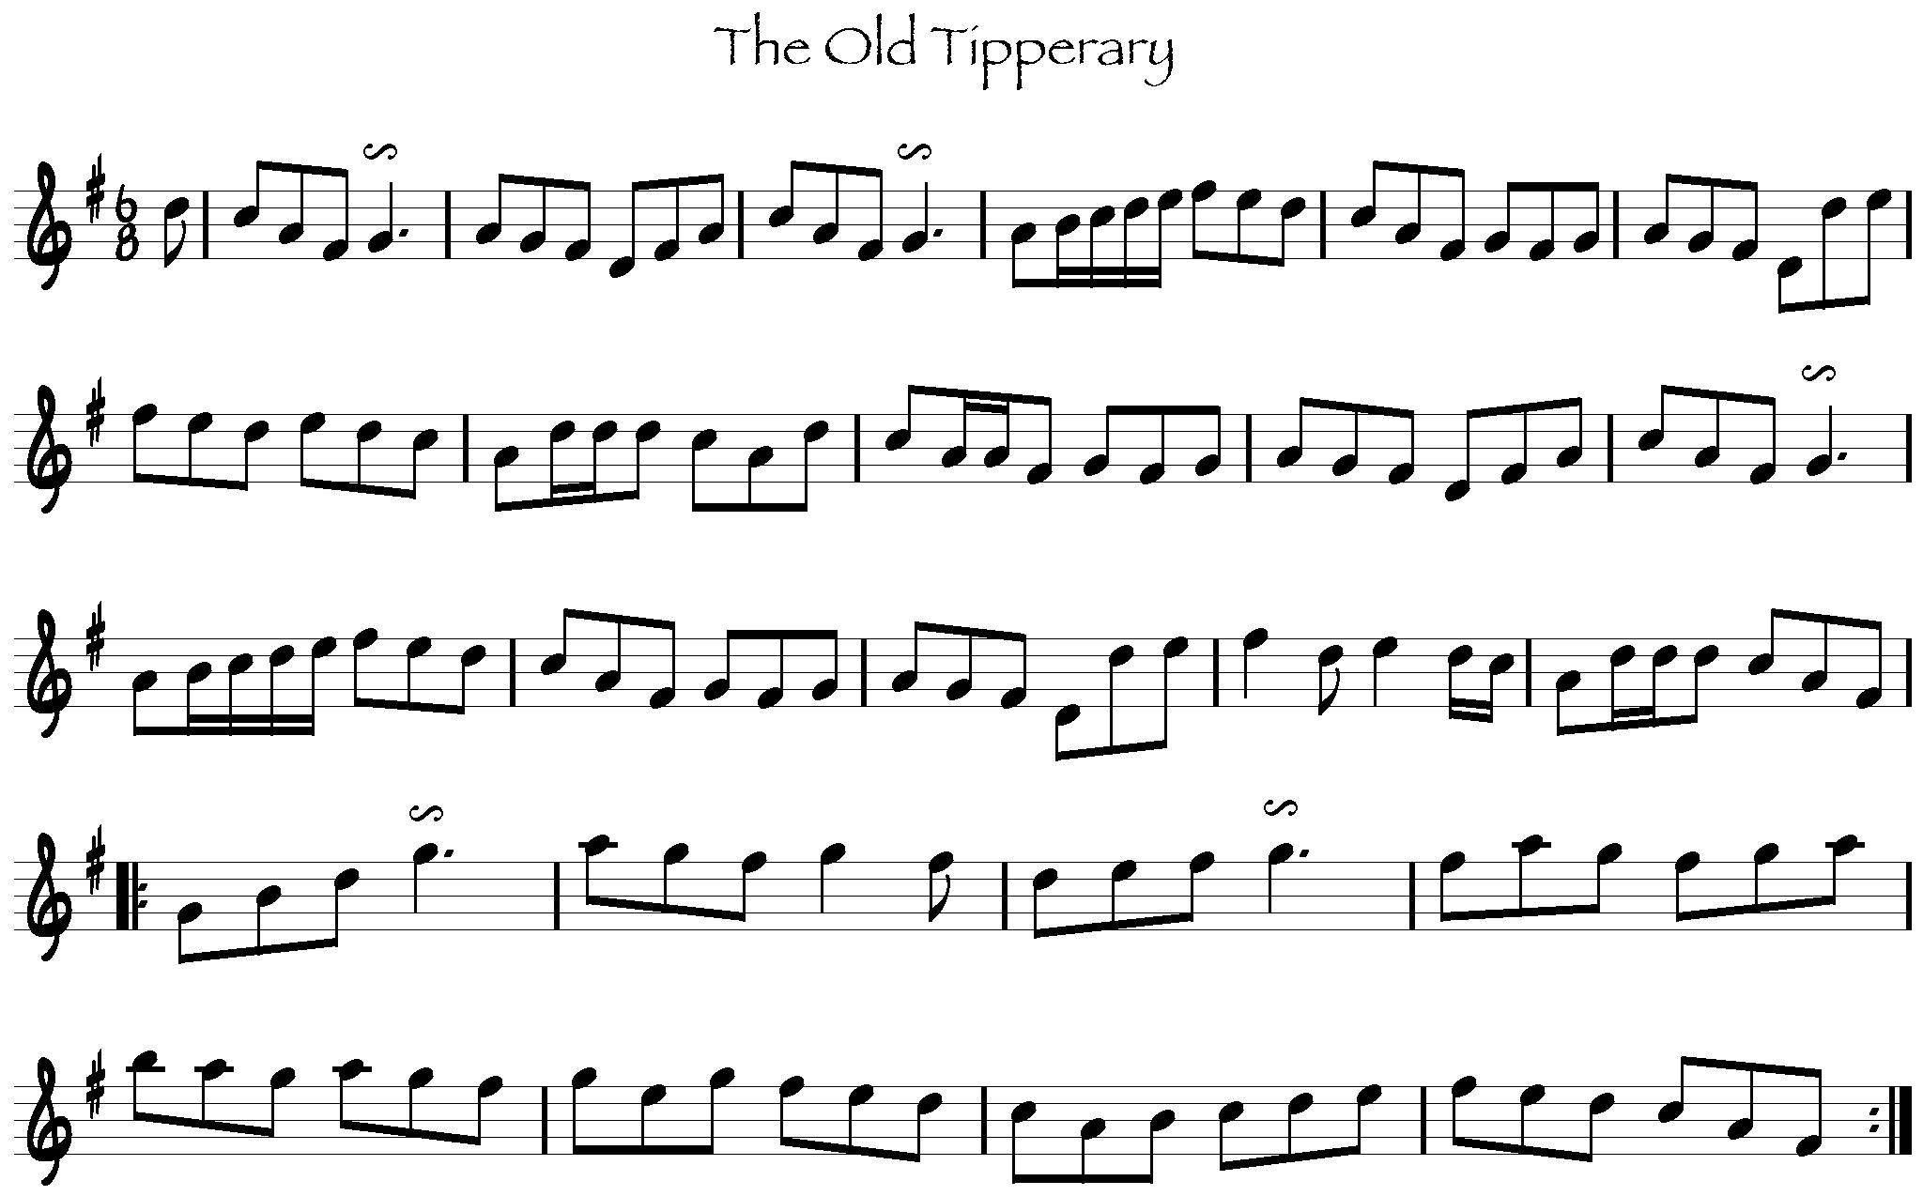
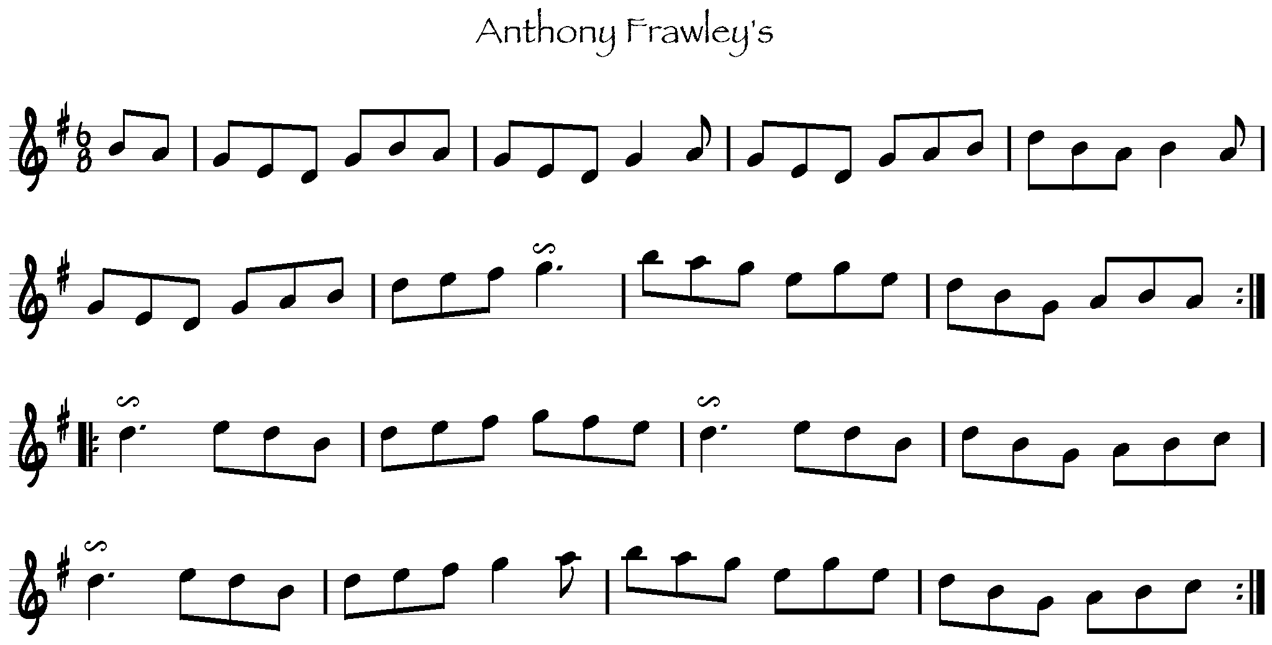
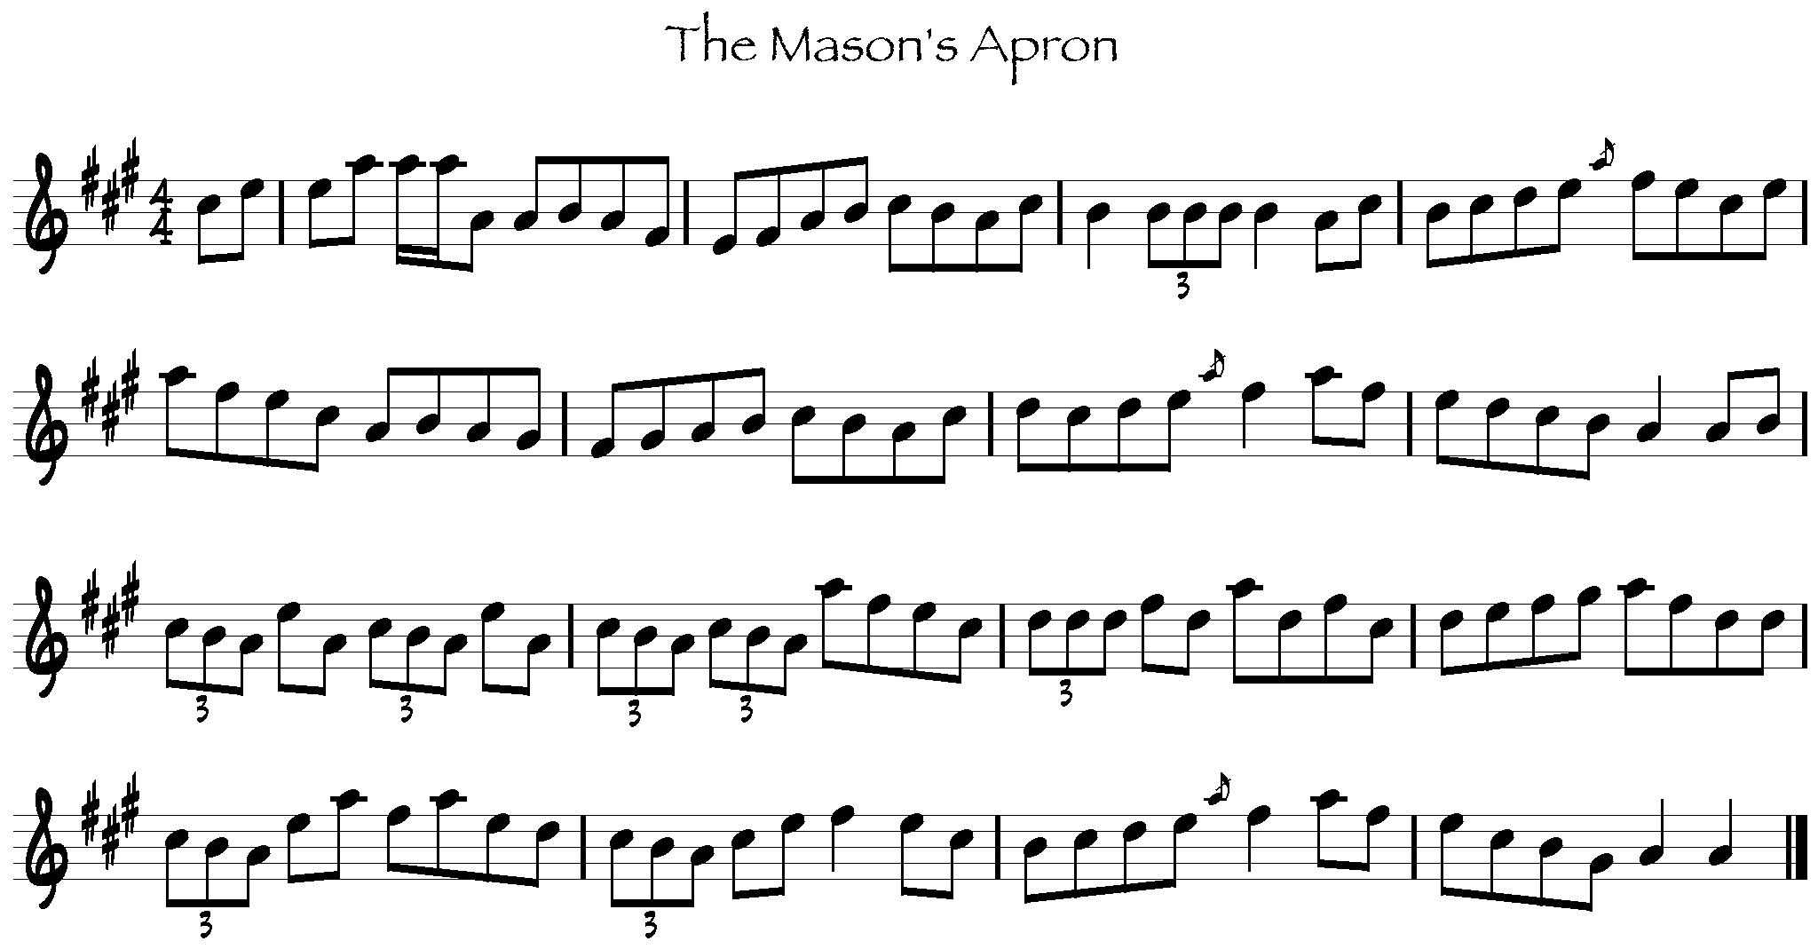

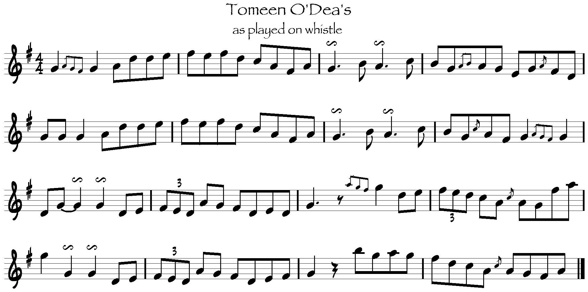
Appendix 2: Patrick Kelly Interview, Mick O Connor 1972

Patrick, would you tell us about your music: it’s not just Clare music, it has origins in Kerry.

Yes, I would say that it has origins in Kerry because my father got a heap of music from George Whelan, the blind fiddler that came in from Kerry, maybe 80 years ago or thereabouts. And he left a lot of music here in West Clare, but he didn’t go north, never went into Miltown, which surprises me. But he would have stayed a very long time here because a good part of the music in West Clare that I heard was played and taught by George Whelan. I saw and heard and played with a blind man by the name of Schooner Breen, that’s buried thirty or thirty five years, probably, and he wasn’t a great player, but he had a lot of music that he got from George Whelan. Played on the fiddle. Then I heard my great friend Denny Mescall that every tune he got was from George Whelan, every tune he was able to play was from George Whelan and I don’t believe that he ever altered a note, and he absolutely knew nothing about music but everything he got he held it until the day he died, which would be around 1934 or 5. He was probably 84 or 5 at that time, and I would say that he played good music up to the age of 80, a very active man and he’d spend a lot of his time going around the country teaching music to people such as __’s mother, which he walked seven miles to teach her music from __ to ___ and maybe he’d do that a couple of times a week, but he taught her a lot of music I’m sure. He had a wonderful collection of music, but he didn’t leave any really good player after him because the man was a small bit deaf and he always insisted on leaning on the bow, and that was the only problem. He had a wonderful bow hand, one of the best I ever seen. Of course, Thady Casey was another very good player and had a lot of music and he used to say himself that he wasn’t a great fiddler but I thought that he was very good, and that tradition went dead in West Clare when Thady died.

He’s not long dead, is he?
No, about twelve months probably is all. He was a wonderful dancer, of course.

And your father played as well?

Yes my father spent his life playing music, but he died young. I was young when he died. I had a certain amount got from him, such as the foxhunter’s reel, and a lot of set pieces. But he had a lot of music that I don’t recollect at all. Or probably I did, but I being too young I didn’t learn any music.

Did he play the same style as Denny Meascall?

No, no he did not. Completely different style, I would be thinking. A different style of music. He was a great air player. He had a great opportunity: he had two sisters that were reared in the convent, or were educated in the convent and they had all of Moore’s melodies and one of them was a noted singer. She even knew Doctor Sigurson in Dublin, and she got in with him and he wrote her when he was cruising in the Mediterranean. She was a noted singer and that’s how my father was such a great air player, because he was brought up with them two girls, more or less, which is a great advantage to know something about the song, for to play airs.

Well, a lot of flings and mazurkas, waltzes, schottisches. I played a schottische here, a mazurka here for John Kelly the other evening, the Prince’s Imperial Gallope. Three parts on it – it just came into my head a few days before John Kelly called here.

[plays Prince’s Imperial Gallope on fiddle]

[plays reel on whistle]

Tomeen O’Dea’s reel isn’t it?

Yeah.

Where did he live, around Kilrush, is it?

Killanena. He lived to be a very old man, he was there in a great time, when the great players were born. There was a great flute player at that time by the name of Patcheen O’Loughlin. He came from the north where all the O’Loughlin’s are still there. North Clare. And he was a noted player, flute player. Tomeen knew him very well and he always called to see Tomeen. And Tomeen also played a little on the fiddle, but he was a very poor fiddle player, and he was the only man I every heard playing Gollnaman sanair (sp???). I never heard my father or Denny or any of those old players playing it, but he played it on the flute and he had great wind and he made a wonderful job of any air he played. The Dear Irish Boy was his favorite I’m sure, and he’d nearly put you to sleep with it. He was a man of about six foot four, and he lived to be 93 years of age. And not alone would he have been a great player, but he was a gifted man. He cut the image of the blessed virgin in a stone that he had in the corner, and had a great job made of it until somebody came in one night, sat on the stone, knocked it over on its side and broke the nose. So he came at it again and he repaired the nose, but it wasn’t a great success the second time in that it was when he had it done first. He made a fiddle then, he made a wonderful fine job of it.

You hear a lot of this: I remember talking to Paddy K from Donegal, he told me he made a fiddle when he was five years of age. Even pipers, Willie Clancy, you want to be some other craftsman or handy like, to be making reeds, or to make your own parts.

Oh the reeds are a very important part of it altogether, that’s beyond an ordinary person to do a thing like that. Tomeen had a very good fiddle. But then I heard on the radio the other night a man playing a fiddle that he made out of a piece of a motor car, and so on and so forth. But we had a man that made a fiddle out of a scrap can, when petrol came out first, ‘twas in two gallon cans they were. And the famous blacksmith of Glenbeg, John Harrison, made one which sounded better than Tomeen’s fiddle

I want to ask you, Patrick, did you know anything about the Moloney brothers, the pipe makers?

Oh I did – I heard Harrision talking about them long before they were ever heard of. Harrison was the blacksmith, and he was a great dancer and a great singer. Every piper – he even brought – the man that died in Dublin from the wall there – he brought Johnny Doran. John Harrison was an old man when Doran was around, but when he heard Doran he had him up there for two nights and two great nights they were. And he was delighted to see and hear Johnny Doran, because of course, he spent his life after famous piper Garrett Barry. Garrett was blind and he had to be conveyed from one house to another, whether it was a mile, two mile or ten mile. And Harrison was very interested in music, he was a very good dancer, very light on his feet and he was a gifted man. He made a fiddle, and a dulcimer, and he put a light up on the stair that frightened half of West Clare before satellites or anything was every known.

You were saying about the Moloney brothers.

Yes, I heard him talking about the Moloney brothers long before anybody knew anything or heard about them here, that they repaired the pipes for Garrett. Garrett was buried probably around eighteen hundred and one or thereabouts, and the man brought him from the __ side up to Ennistymon was a man by the name of Din Donoghue, and he got people who were noted dancers and musicians, and he says, Mrs. Galvin was one of the family, and ‘tis from that.

That’d be Mrs. Galvin the concertina player.

No, fiddler. She was from out of the south, but Din drug him [Garrett Barry] in his horse and side car, from Cloneen up to Ennistymon hospital, and he was admitted there as a labourer, and he died about 1901.

He was wonderful but Harrison said that Johnny Doran was a better piper than he. He said that.

Willie [Clancy] you see had a great advantage because his father was in and about there at the time of Garrett Barry and his father had a lot of music, and he had a lot of dance music. And Thady told me that he danced to Garrett Barry, and he had no boots on him. Of course, very few youth had any boots at all. Thady. Harrison also told me, we talked about it in the car, he made the first ha’penny bike we had seen here in West Clare. And he told me that he walked down to Limerick without shoes, but he had them on his shoulder, put them on going into the city, and took him of again coming out and he jaunted home without any boots. He was an awful blacksmith, he was fifty years before his time.

You also knew Mrs. Crotty well, didn’t you?

I did, I did. Many a night I spent with her. She was a wonderful woman, she didn’t mind, if she got a mile outside the town, she didn’t mind if it was burned down to the earth, when she was gone out of it. Anyway, it was all music and being in Miltown, Miltown was her favorite spot, Willie and company.

Would you say there’s a difference in the music of West Clare from this side down and from Miltown up?

There is, mind you, there is a difference in the style of music, because Thady’s style and mine were completely different altogether. He had music from a great player up there, he called him O’Donnell, and O’Donnell had great music because Thady had great music. Everything he played was good.

You were talking about Denny Mescall, and you also mentioned Daniel Mack to me.

I don’t know very much about Daniel Mack, but I got a tune or two belonged to him, which is O’Connell’s Farewell to Dublin on fiddle, but I didn’t know anything about him. He was a very old man when I saw him play, and he was as near to me as Denny, but he wasn’t traveling out too much at that time. But he had a wonderful collection of music.

Would he have had this music from George Whelan?

Well, mind you, I’m not sure of that – that’s the whole thing, I don’t know about him. But he also had another brother that played, but he wasn’t as practical as Daniel because he didn’t teach music, and he was James, he had a lot of music too, I’m sure. A very nice man though – he had a son also that played, Seamus Mac, a postman up to recently, and he still had his father’s music, but somehow he got careless and didn’t follow it up at all. He was well able to play at one time. There was an ad for fiddlers for country dancers when the country dances were in full swing, but the gramophone put an end to a lot of that music when it came out.
Appendix 3: Patrick Kelly Interview, Séamus Mac Mathúna 1966

Get back to Doran again. Would he play a long batch of music when he’d play?

Oh he would.

Three or four reels together?

Well, I would say that he did, but it strikes me that he played the reels single, that he didn’t double, if my memory serves me right. A reel was never played double in here with the old fiddlers at all, was only played single. The parts were only played single: they weren’t played double.

And Doran did the same?

I think he did. And I heard another peculiar thing that night with the lads, you heard them playing the Bucks of Oranmore that now. Well everyone you ever heard playing it, except myself, they started it the last part, and it strikes me that those started at the part that I start. Did you notice that?

I think so.

I’d say they did.

Doran—was he collecting that time now?

Oh Christ, he had an assload of money, he brought an assload of money out of West Clare. Oh a hat or something would be thrown down on the ground, or something like a sieve. I don’t know exactly what it was now. I met him again back in Kilkee at the races, following him around like every other gom, sure, and he was, he couldn’t keep it in. But I don’t think he had someone with him in Kilkee.

Used Willie be around him?

Probably – not in Kilrush. Oh, he was in the wagon with him – most of the music Willie got was off the wagon, he was up here in Clahans and various places and Willie, that’s how Willie followed him up. But there was a famous fellow in Glenbeg by the name of John Harrison, and a famous doctor by the name Paddy Hehir, and they spent their life as young lads following Garrett, and John Harrison invited Johnny Doran for a night’s music, and he did arrive in good time, and the house was full, street was full, everywhere was full, but an act of parliament had been passed here, I think by the Fianna Fail government at that time, that allowed only about 30 people in a house for entertainment, a dance. I think around 30 people. And guards landed in due time out there, and cleared the whole goddamned place, but Harrison brought him again, and he said that he was a better piper than Garrett Barry. And Harrison was a kind of good dancer too. He went around cutting stones of course, I saw him cutting locally.

Was there much singing around here?

No, there’d be no tradition in their singing. It was the one thing that was never here, was any touch of traditional singing,

You knew Denny fairly well, I suppose.

He was the best of them lads I knew because the rest of them were dead when I was getting strong, and Denny was alive. And I knew the Schooner, the Schooner he got small pox, but that he remembered to see the birds. Remembered to see the birds, he was three years of age. And it struck your grandfather back at the bridge too, he was another one that it struck.

Denny Mescall, did he teach many himself?

Oh, he taught it. Didn’t he walk back from where he lives to the protestant church in Kilkee to teach Magrue’s wife music, two bob a tune. And you can put that down anyway to about 14 miles a day. That’s a long run. Well, he done that. But I was always interested.

The one thing Denny didn’t do, or that he did do, he always insisted on leaning on the bow. He was a small bit deaf, and the majority of the fiddlers he left were all a bit on the rough side.

Baby John had a few students, didn’t he?

He did, but sure, they were no good either. They weren’t worth a damn. There’s a great art in teaching music. Well there was another thing in favor of anybody, which was in Denny’s favor, and in Daniel Mack’s, and my father’s favor. Once they started teaching, whatever age they were, they kept it up, and they could call, half a part of a tune, and you playing below, and they’d hear and they could correct you in whatever mistake you made. But they were very particular about the bow hand.

Well, fiddling is fading in West Clare, isn’t it?

Ah, dead and gone.

[speaking of Tomeen O’Dea] and of course, it was all slow. Their music was slow music, more to be listened to than danced with. And to finish up with Denny Mescall going out to dances, playing, was that he was nearly kicked out of it. He wasn’t fast enough – the times had changed, the rhythm had changed. They wanted sets that were fast, and he couldn’t change over.

Your father taught you music.

Yeah.

Here in the house.

Yeah.

What was it, he was a farmer?

Yeah – he hadn’t much to do: he worked more with his own people back near Michael Murphy’s.

Would he have a type of people that come, was it young people who came?

‘Twould surprise you the advanced people that came, and people that I had no account of

Had he a special time?

No, no – time didn’t matter in them days. Time didn’t matter.

Would he take them one at a time, would he?

He’d take them single. Well, if they were good enough, which you often would have them. I could sit down in the corner on two stacks of turf, of course there was turf in every corner that time, and I could be sitting down over there, listening to him teaching the music, and I could play that when they were finished.

You started on the fiddle at what age?

Around ten.

The Foxhunter’s now, would he tune up the fiddle for that?

Oh, he would.

Would he give you lessons as well, or would you just pick it up?

Oh, he gave me lessons, he did. Such as that Apples in Winter, or Gillan’s Apples I should say, or the Ace and Deuce, things that I do remember. And the Job of course, but he played another tune then that I never heard, or knew anything about, The Downfall of Paris, which was this old one up in Glenbeg that heard it played on the radio years after he’d been buried, they told me that me father played it. ‘Tis in the book.

He taught two bands then, of course. He taught a band in the period, maybe around ’92 or ’94, and then another in 1917. He was a great nationalist, which very few of the Kellys were.
Appendix 4: Tom Kelly, Jim Kelly and Barry Taylor Interview: Brendan Taaffe 2004

I wouldn’t know much, is where I’m starting from. I know that he was from Cree, and that he got some tunes from George Whelan.

Well, the funny thing about it, you see, the people that knew him are all dead and gone. The people that knew him well, when he was playing and when we was going well in his young days. You know, Paddy McInerny, Micky Kelly, Paddy Ryan – all that old generation, his own generation, are all gone. ‘Tis hard to get anyone now to talk about him. And I didn’t know much about his young days because he wouldn’t talk much about where he spent his time, where he was, only that this MacMahon’s that was near us now at home, that was one of the places they used to have great nights, and it went on every—it wasn’t one night at all—but every night, and even in my time, it kept on and on. We went in there in the night and the records would be put on and the set would be danced. You would dance the set to a record. To Michael Coleman and Paddy Killoran and all those fellows.

And your father wasn’t mad about the impact of records.

He wasn’t, but they had nobody to play for them and they wanted music, and they wanted to dance, and they loved dancing because the old woman, she step danced and they danced sets. The daughter taught everyone in the area, Mary, because she stood there on the floor with you and when it was time for you to start, she landed you over there. She was a fierce big strong lady, and well able to dance. So she taught everyone in Cree to dance. But I remember my father describing long ago, ‘tis an eye-lamp would be hanging up on the pier just behind him, with a globe on it and two wicks on it and that would be the lighting. There was no electricity you see, and he would be playing and of course he would never be blamed and he would be under it and up would go the bow and he’d just hit the globe and down the globe would come on top of him. But there was always someone blamed and never him. I often heard him telling that, and I heard him telling one night, there was two rooms, one room down there and the partition only went the height of the wall and there was a knee roof on the place, and in the middle of the set one night, the tick and feathers came up over the top of it and landed in the middle of the floor on top of the lads that were dancing. The tick and feathers – they used to sleep on the bed—and a couple of lads took it from down below and flung it right out over and it landed right in the middle of the floor. Oh, what usen’t go on there. There was a hasp on the door, there was one of them on the door and, of course, a lad outside he put on the hasp and put a piece of tin through and, Jesus, you couldn’t get out, you’d have to go through a window. He used to playing for the dances, one time.

Would it be just himself, or would he have been playing with someone else?

I never heard him saying that there was anyone else there, but probably there were.

And that would have been every night of the week?

Ah well, he wouldn’t go every night of the week. But he’d probably go at the weekends and that. But outside of that, there’d be farewell parties, mostly for America. Them were the big things when I was a child. Someone going to America, there’d be what someone would call an American Wake.

And what years are we talking about?
That would be the 40’s. In the 40’s now.

And when was he born?

He died in ’76 and he was 71 years. 1905 he was born. He was born in Cree. And his father died when he was 10, so he was well able to play at that time.

And he learned from his father and George Whelan.

Well, some lads will tell you that it’s the father that learned his music from George Whelan, because I don’t know what year did George Whelan come around, what year it was. That I’m not sure, and I don’t know is it written down anywhere.

So Whelan, he would have traveled around?

He would, I would say he would have traveled into Miltown. Did you ever hear talk of him?

(BT) No, I don’t think he did. As I understand it, he actually traveled more around this area. Doonbeg, Kilmihil, Cree. Cooraclare, maybe Kilrush. Because, presumably, he came across the Shannon.

Well, there’s nobody living now, I would say, that would tell you. Nobody knew about his exploits at all.

Your granddad would have been a good player as well?

Yes, the grandfather was a good player, so they said.

On fiddle.

Yeah, on the fiddle.

That was Tim.

Tim Kelly – He died when my was father was only 10 and he was well able to play at that time, so that picture you see there on the front of the CD, he was probably about nine years that time, when that was taken.

Did your grandmother have music as well?

No, she didn’t. The music was from the Kelly’s.

And brother and sisters?

None of them. None of them ever played. Pat Joe had a few tunes on the tin whistle and then gave it up, forgot about it.

Your uncles and aunts I mean.

No, they had no music.

How many were there?

Well, from my mother’s side I have two uncles and an aunt. My father was an only child. So that side of it is all gone.

And of yourself and your brothers and sisters, you don’t play.

No we don’t.

(BT) I should say, because Tom would be too modest to say it himself, that Tom’s a fine singer and that most of his family are excellent singers. And all of the family have a really great interest in the music.

Oh, they’re all interested. They’ve followed it up all their life in England now, most of them went to England in their young days and wherever they went you’d hear them saying, we were such a place on Sunday night. Of course, great pubs in England then, and especially round London. They used to go in and they met all the musicians that were there, from every county.

So, your grandfather, would he have taught Patrick to play?

He did yeah, he taught him to play. Now, I don’t know how he got the rest of his music, whether he picked it from records or not, but I suppose there was always people moving in and out of the area. Willie Clancy now was a regular caller to our house, regular caller. I often remember Willie coming. Junior an odd time, very seldom. The Caseys in Quilty now – Bobby and Thady Casey, himself and Thady were great friends. And there was a fellow in Kilmihil by the name of MacNamara, Daniel Mac. He used to always talk about him. He was another one that he used to frequent with.

And Mrs. Crotty?

And Mrs. Crotty, and then there was a Mrs. McInerny here in Cooraclare, there’s a little garage now right across from the church gate, there was another place he used to always call, because she was a neighbor of ours from Cree just at the back of our land. When he’d go to town, and he’d go to town fairly often, cycling, there was no other way to travel at that time. And coming home at night he’d go in there. And Mitchell Lillis was a smith who lived in the village and he lived just beyond the turn in the village. And he’d two big open doors on the forge, and he’d see everyone as they’d pass. So he’d see my father passing in the morning, and he’d have a set ready for the night then. Patrick Kelly has gone down today, there’s going to be a set at Jackie’s tonight. Jackie McInerny was his name, and the set would be there that night. Because Mrs. O’Keefe told me she often went up to the door at night to hear them dancing the set. There’d be a set there every time.

What would he be doing in the town?

He’d just go for messages then, some business.

He was a farmer here?

He was a farmer, yeah. He described one day going down to Kilrush with a toothache, a terrible bad toothache, so he decided that he’d go down and have it drawn. He was just going around the corner of Crotty’s below and he sees this man on a butter box playing the pipes. He pulled up beside him and stayed with him for a while and who was it but the famous piper in Dublin that the wall fell on him – Johnny Doran. So they went into Crotty’s and spent the rest of the day and a good part of the night and then came home after that, and he came home with the tooth and it was buried with him. And I told a story one night about one night that he was playing in Quilty with Joe Cooley. Himself and my father were backing up for Leo Rowsome this night, and a fellow said to me afterwards, he said “If Leo never came, we were going to have a mighty night.” But Leo came anyway – but what I didn’t know is it was for the famous piper that the wall fell on him. A benefit thing –

Barry was telling me earlier that when he learned tunes he had a very specific bowing for each tune.

Well, the likes of Barry would know that better because he might talk to Barry about that, but he’d never mention it to us now, about the bowing technique. But himself now and George Whelan, what do you call the schoolmaster that was in Kerry – O’Keefe – they could knock six notes out of the pull of a bow, they were the only two.

You know the way he tuned the fiddle for the Foxhunters, were there any other tunes that we would play that way?

He used to play one other jig, I don’t know whether I have it or not – he used to play a jig when he had it tuned up. And he’d leave it up, he’s leave it that way, and he could play away a few tunes after that. But the Foxhunter he wouldn’t play that often. He could play several sessions and he’d never play the Foxhunter, because he always tuned the fiddle up to do it. So, except at the end of night and someone would ask him to play the Foxhunter and then he might play a couple of tunes after with the fiddle still tuned the same, the same tuning.

(BT) And he did tell me that later on in his life, and I’m not sure of the logic of it, but he did say that he actually he tended to tune down to GDGD to get the same effect.

Sure, you’d break fewer strings that way.

(BT) He said he did as he got older.

Well, on all the recordings he’s tuned at least a step below concert pitch.

(BT) A lot of the old fiddle players tended to tune down, rather than concert pitch.

Well, how would they play then with a concertina player like Mrs Crotty?

(BT) Well, you listen to a lot of Mrs Crotty’s concertina playing and she plays things in very funny tunings. She doesn’t play in standard pitch settings. A lot of musicians played a lot on their own, they wouldn’t be playing all the time with other people, because there weren’t those other people to play with. There wasn’t the profusion of musicians we have today.

(TK) There weren’t no, because they weren’t there. I remember a fellow -- Micho Dick Murphy. Micho would come to a dance here in Tullabrack, and he’d have to be brought on a bicycle, bring in on the bar of a bike from Kilmihil back to his, and he’d play all night on his own on the concert flute. Drink a few pints of porter and be brought home then – as long as there was enough porter he’d keep blowing into it. And he had a lovely style of playing, beautiful.

How did Seamus Macmathuna find your father in the first place?

Ah, Seamus was only local. He only came from about a mile over the road. He was born in the parish and we played football with Seamus when we were young. Seamus describes one night he was in Cooraclare around Christmas and, of course, he was always a man to sing a song and he’d put everything into it when he’d be singing it. And they were outside Martin Knowles’ one night around the Christmas and late in the morning, about three o’clock in the morning, and there was five or six or eight them outside the door and Seamus began to sing this song and he closed the eyes and he’d get right into it, and when it was all over there wasn’t a sound. Not a sound – he looked around and there was nobody there. And there was the squad car across the road, and the cop stuck his head out and said, “Will you go away home now, sonny, and let the people of the village sleep.” “I had to hang me head,” he said, “and walk down to the village.”

And did he broadcast it on the radio, the recording?

Well Comhaltas never got much to do on the radio at all. You never heard any Comhaltas on the radio at all. No it didn’t get much airing at all on Radio Eireann.

But you hear about these other players – Sean Ryan was on the radio, Paddy Canny was on the radio.

But it was Ciaran MacMathuna that played them you see. Because he had a half an hour’s program every week, but my father and Ciaran never saw eye to eye. Oh not at all. Because Ciaran was a Limerick man, he had a degree in agriculture and he knew nothing whatsoever about music, only what people told him when he started. In town one day, he was recording inside, and there was somebody from around– a very good concertina player, but he had his pants all torn and he wasn’t able to fill his glass for him, and Ciaran wouldn’t take him. And my father wouldn’t take that kind of stuff, and he told him what he thought of him. So that was the end of the friendship. And as you know, Ciaran is still playing the fifteen or twenty players that he made thirty years ago.

(BT) He’s lived most of his life off of a very small amount of work.

(TK) A very small amount of people, he’s spent most of his life living off of them. That’s the way he lived- people looked after him, and he had to be kept drinking all day, and all night. That’s how he lived his life. But my father wasn’t taking any of that.

And your father didn’t leave the area much.

No, he didn’t. He never went out of the country. He was in Dublin a couple of times in my memory, that’s about all.

Would he have gone to the Oireachtas or the Fleadh?

Except was quite near. As far as Ennis, that was as far as he went. I remember he went to the Fleadhs that were in Kilrush there. There were some very good Fleadhs there years ago. No, he wasn’t a man for travel at all. I remember one particular day, we were at home and we had about ten acres of hay down, just west of the school there, and there was no way for turning hay or making hay. ‘Twas all hand fork – turn the hay and rake it in with a rake and get a horse and put it into the trams and bring it home. But three or four fellows came, they were Australians, fiddle players, and they came into the meadow above and we were all there, and they were talking away for about quarter of an hour and the next thing you know he stuck the fork and went off and we didn’t see him for two days. We were left saving the hay. Ah, it was something that would take you away every now and again. He didn’t come home until all hours of the morning. He didn’t want us to learn music because he saw what it done to himself and to other people. They stayed out, they stayed out until morning. Because I remember my mother describing looking out the window one morning, waiting for him to come home and bring in the cows to get them milked. And she looked out and there he was out on the road, sitting up on the pier of the gate, in the morning, and there was a fellow that lived in the house right across the road from us. And he was step dancer by the name of McInerny, nothing to Paddy now, but he was on the road dancing. And this was before the road was tarred now, and my mother could see the dust coming up over the fence. Wasn’t that some picture? Of a six o’clock in the morning, of a fine summer’s morning, and she could see the dust coming up, and he above only playing the fiddle and your man dancing out on the road.

(BT) Your father wasn’t much of a drinking man, was he Tom?

No he wasn’t – I never saw him drink a pint. He’d drink a half a pint, but never a pint. No.

(BT) I remember Ollie Conway telling me, in Mullach, he’d ramble up there and Ollie said he would always just as soon have a cup of tea and a bun than any kind of drink.

(TK) No, he wasn’t a drinker at all. Oh, he probably was in his young days – most young people when they went out, they tasted it. And there was always drink taken with music, and for that we wouldn’t be in Cooraclare either.

(BT) Well, I think quite a few people weren’t, and drink wasn’t as plentiful then, was it? I mean, people didn’t have the money to go into pubs to drink, and it would be a big occasion if you had a half barrel of porter or something in the house.

(TK) That’s right. They’d bring the barrel of porter in the house and tap it, and fill the glasses then all night.

So the music wouldn’t have been in the pubs so much as in the houses then?

Oh god, no. Not at all. No – there was some pubs. I remember now, when I was growing up in Cree, Walsh’s was the place for the music. Every Sunday, ‘twould be like Carnegie Hall, and the crowd of people that would be there, and there’d be at least nine or ten singers there. And it would go on all day, ‘til Mass time, and then into the night. In the old pub. Because I remember my father saying, whatever you do, don’t you let me catch in that pub up there behind. We used have to go in to hear the singing. It would be mighty.

(BT) Did he play there?

He did, but not in my time. He used to play at Flynn’s. Himself and Sean Flynn were great friends, Sean also played the fiddle. He was a great air player. Very sweet music.

Did your father have any students? Did he teach anyone to play?

No, not as far as I remember. I never saw anybody coming to the house.

And he didn’t want you all to play because he didn’t want you coming in at all hours?

He didn’t want us coming in in the morning, falling about the place. No.

And he’d come in for the morning and work straight away, work for the day?

Oh well, the cows had to be milked the first thing. And the milk go to the creamery. That’s one thing that had to be done on the farm. I suppose it would be early to bed alright that night. But Mrs. Crotty and himself were great friends, and she was great friends with Mary’s uncle, who was a priest in Long Island. And but for him this record (Patrick Kelly from Cree) never would have gone ahead, it was amazing. He had such a hand in it. He such a hand with Mrs Crotty that he brought her to Dublin to make her record, a 78. Monsignor O’Dea, on Long Island. Halfway out the Island. We used to call him Father Martin O’Dea. He couldn’t play, but he loved music and he could put a name on every tune, as it was played. And he used to bring the music over to America, you see. Because famous Paddy Killoran was beside him: Paddy got Multiple Sclerosis in his old days and couldn’t play, and he [O’Dea] used to go down the night and play the music for him. Bring down these tapes that he used to make at home. So the tapes were outside then and he died 25 years ago that man did, Father Martin O’Dea and he left the tapes to a niece of his. And she brought them home here about three years ago, and she left them in at the house here some day that I was gone working. Mary just took them in and put them into a press inside of the kitchen and thought no more of it. And they were there since. I didn’t know they were there, and there was a woman then from Kilrush and she wanted me to make a tape I made for her 40 years ago. Father Martin used to come here on the holidays, and I had made these tapes.

And he would bring them to America to play for Paddy Killoran?

That’s right.

He used to play a lot of set dances. An Suisin Ban, the Blackbird.

(BT) But I think one of the things Seamus said, it was a bit of a pity that some more of the slides and polkas weren’t included.

Yes, Seamus was anxious that they would because he said he was one of the best jig players in Ireland. It was a pity that there wasn’t more of them put on. But when you’re in Clare you play reels, and if you don’t, you aren’t wanted. That’s as far as I can see, all my life.

So the tapes that Ceol an Chlair were made from are totally different tapes than the new album?

Oh yes, totally different. But like, as you know yourself, you’ll probably play much the same music most nights, for sessions. They were in different places along the way, but it was much the same music all the time.

Players now will have loads and loads of tunes—he wouldn’t have had as many tunes?

No, he wouldn’t. I forget now did I hear him saying that his father had 200 reels.

And what players would he have spoken well of?

The Caseys—Bobby and Thady. In fiddle players, this Mac from Kilmihil, he was always talking about him. Danny MacNamara. Then there was a fellow just above Brown’s there, living in there in the bog: Denny Mescall.

Now this fellow Martin O’Dea that I was telling you about. He brought Mrs. Crotty to Dublin to make her first record, the 78 with the two tunes: The Reel with the Birl and The wind that shakes the Barley. But you see as it was with all the old musicians, and as it was with my father on that tape there, they all played single tunes. But he had her told now, you’re to play two tunes after one another without a stop. Father Martin had her told, and she started after leaving here, practicing, and they were in the Curragh of Kildare when she got it. I often heard him telling that.

And the way she played the Reel with the Birl is quite similar to the way your father did.

(BT) I guess he must learnt it from her actually, because the reel with the birl is a bit of a conundrum as to what it really is. The first part is just a straight forward Drowsy Maggie, and the second part, well I think Mick Tubridy reckons that it comes from a tune, Sleepy Maggie, which I think is the next tune in O’Neill’s to Drowsy Maggie. But I’ve tried it and it doesn’t seem that to me at all. When you try and play it on the concertina, Drowsy Maggie, in the key that she plays it in (she plays it in Am, if I remember rightly, on the middle row of the concertina, it is almost impossible to play the standard second half of Drowsy Maggie on the middle row because the notes aren’t there. So I think, my interpretation, that it’s an adaptation of Drowsy Maggie.

(TK) ‘Tis unique to her, anyway.

I’d say that Martin Hayes got a lot of music from your father. His version of the Morning Star and O’Connell’s farewell.

I don’t know really. The east and the west Clare musicians never got together much, years ago.

(BT) Well, you say that Tom, but I’m not sure it’s entirely true. Martin Rochford was a great friend of Junior Crehan’s.

(TK) Oh, he was an exception. Martin Rochford, you see, had a lime lorry and he traveled all around the west delivering lime. And he used to call to my father. And I remember they’d a few times at Brown’s, they had a little shop at the corner there. Mrs. Brown was from Cree herself, and she had a brother who was Paddy Cunningham, who was an out and out flute player. My father classed him as the “Matt Molloy of Cree.” He was probably older than the rest of them around, and we thought it was fright for Paddy to give up playing. But Paddy was 80 years like. He lived over about a mile beyond our house, further on towards Glenenagh. He’d be almost across from Paddy McInerny.

(BT) And did your father play with Paddy Cunningham?

Oh he did, yeah. Of course, they had a marching band in Cree, before my time, because I remember – well, there was flutes there anyway, and there was the big drum. And there was the cymbals, and a couple of small drums. I remember when I was, I suppose about 9 or 10 years of age, a priest came back from England. He was Kelly from Cooraclare – he was in Scotland, he came back and he started a football team between Cree, Droomilihy, Cooraclare, and there was a team here. He put four teams together and he put up a set of medals: football had kind of died down in the place, this time, and he wanted to start it up again, so this is what he done. So he put up the set of medals and he put four teams together. And on the day of the final, we were against Cooraclare, Cree were against Cooraclare. And to make it a big occasion, they got out the drum, and the whole menagerie on that particular day. And that was the last time it was ever seen. It’s not out anymore.

So when did they have this marching band?

That was, around maybe 1945-46.

And was Patrick in the band?

He was, yeah, playing the fiddle. They had fiddles in it, Mickey Kelly I remember. Tommy Golden, he was in it, my uncle, he played the drums. I don’t know if they have any picture of it. ‘Twas the first band ever to broadcast on Radio Eireann was the Cree Ceili Band, and it was done below from the town hall, through the phone. And Mrs. Crotty was inside in the pub and she went out to tell them to tune down the drums that they were too loud. ‘Cause she could hear it on the radio inside. A ceili band.

And who was in that?

All that crowd now, probably Paddy McInerny and Paddy Cunningham, Tommy Golden and my father and all that crowd. And I think a couple from Kilrush played with them that are dead and gone now, I can’t name them anymore.

So there was a Cree Ceili Band?

There was.

And how long did that go for?

I don’t know – that’s history now. That was the last day it came out, was the day we won the set of medals in Cooraclare. Pat Joe was playing, my brother, he was on it. It was back in the forties.

(BT) And when you say they were the first ceili band to broadcast on Radio Eireann, that must have been back in the 20’s

(TK) Must be, yeah.

‘Cause the Ballinakill were playing in the late 20’s.

Well, if you ever get a chance to check that out now. That’s what I was told, that it was the first ceili band to broadcast from Radio Eireann, and it was broadcast from the town hall in Kilrush, right across from Crotty’s there. And Mrs. Crotty did a complement by going out to tell them to turn down the drums because they were smothering the music with it.

And your mother, where did she come from?

My mother was a neighbor, within half a mile of us. She was Golden by name. She was Golden from Cree. They called her “Dilly,” which wasn’t her real name. Margaret she was, but she was always known as Dilly.

[patrick’s father – Tim Kelly, mother – Marie Killeen] speaking of Marie:

She was a very small woman actually, because you can see her on the sleeve of the CD there and sure you see her standing by my father and my father was only small, probably 5 or 6 or 7, and she was a way smaller than him.

And when would your father have married your mother?

Oh, I couldn’t put a date on it now. As a fellow says, I wasn’t around then.

(BT) Who’s the oldest in your family Tom?

(TK) Susie May, my sister.

(BT) How old is she?

(TK) She’s 73 gone.

(BT) So she was born about 1931.

...tea break…

Now, when you were growing up around here, would the only music you heard around here have been Irish music, or would have heard jazz and other things?

Well, it was mostly Irish music. I always remember there was fellow used to repair bicycles, just above Cree, Bill Green was his name. And he started selling records, and Susie May went back and bought a record one day. ‘Twas burned. My father burned it, that’s a fact. It didn’t last long.

(BT)
Did you have a record player?

(TK) Oh we did. A gramophone.

(BT) I’m surprised your father let a gramophone in the house.

(TK) Oh, the gramophone was there.

(BT) He was very ambivalent about 78 records, Coleman and the kind. He said to me he thought they were great, wonderful players, but it kind of discouraged local musicians. Some of them were kind of put off by the fact that suddenly they heard Michael Coleman and they had been scratching away for years. And everybody had been happy with them playing, and suddenly Coleman appeared on the scene and they were afraid of this. And it put a lot of them off playing; others found it inspiring because they learned from them.

So, you wouldn’t have had 78s of Coleman and Morrison in the house.

Oh, there was, yeah. I don’t know, he probably bought them. They were there though, I don’t know who bought them. But he’d allow them fine, but ‘buttons and bows’, there was no way ‘buttons and bows’ would come in to our house. About the only thing he listened to on radio was the news and Irish music.

So he would listen to Ceili House and the other programs?

All that, and he had his tape recorder ready, his small Grundig, with three inch tapes above on the top of it. And he’d be taping different bits of music all the time.

(BT) He used to have the tape player plugged into the light socket, I remember that. A cable running down from the light socket. The very first thing he said to me, after hello and what have you, was ‘What do you think of Paddy Keenan’s piping?” That was the very first thing he said. He had heard Paddy Keenan on the radio

And what did he think of Paddy Keenan?

(BT) He thought he was great. That’s the thing I remember: he was very up to date with everything that was going on. There wasn’t much Irish music on the radio in that period, very little. Ciaran’s Sunday morning program, and I think The Long Note was on then. But there was very little: there never was much until very recently.

(TK) Yeah, half an hour in the week was the most. And there’d be loads of people writing in about, but what’s the use.

So Patrick would have had an appreciation for someone like Paddy Keenan?

(BT) Oh yeah, he just loved the music.

(TK)Well, Matt Molloy of course, and then Sean Maguire. Thought Maguire was the daddy of them all when it came to fiddle playing. What he could do with the fiddle… I remember he was in the tavern one night. One night, he was there. The tavern, now, was a fine big place, and ‘twas packed, people were so close to one another. And he wasn’t the type now that would play for sets, that was beneath him like. He was an exhibition player, but he played for sets that night, and about one o’clock in the night he stood up behind the microphone and he played Roisin Dubh on the fiddle. Well lads, you’d hear a pin drop the way he played that music. I never heard anything like it. He almost made it cry. It’s something that stayed with me all my life; I never forgot it, it was so haunting.

At Kelly home, Cree.

Jim; My grandmother used to get the snuff there, and if Marty filled the snuff she’d know it was he filled it, because he’d only give the bare amount, but if the wife filled it, she’d know the wife filled it, there’d be a small bit more in it. And they were Marty and Molly Tubridy.

Tom: And they used to torment the life of him, because he used have to have everything right and everything in its place, and one night they put a full tank of water up above the door, the front door of the shop. And ‘twas full to the top with water, and when he opened the door, you see, all the water came in and it hit him and right across the floor. Oh they used to torment the life of him.

Jim: Cree was supposed to be an awful rough spot in those times. So and so was supposed to have said that wherever the devil went by day, he was at the cross of Cree by night. And she also said that any second generation of any family wouldn’t live at the cross of Cree, and it has never yet happened.

So he was only ten when his father died, and an only child. What would they have done then for money, just a ten year old boy and the mother?

Jim: Well, there was no money that time. Money was a very scarce commodity. They were self-sufficient, you see. The people around here, they were self-sufficient at that time, or almost self-sufficient.

Tom: Everyone had their own gardens, and cows for milk, and made the butter. And a pig to kill at the end of the year.

It’s a lot for a ten year old boy, isn’t it?

Jim: Well, you see, all the neighbors would help

Tom: There was a lot of people around, and everyone would chip in.

How did your grandfather die?

Tom: I don’t know what killed him. I don’t know did he get a heart attack or what.

Anne: It could even be appendicitis at the time, people were dying from appendicitis at the time here. And the operation wasn’t discovered for it at all. The people used to poultice to it for the pain in their side and burst it, that’s what they used to do thinking they were doing good.

So the neighbors would come and help with the pig at the end of the year?

Oh yeah. And with the hay and with everything. I remember that was happening in the 50s and 60s, you would have all the neighbors coming in and giving you a hand. There was so many.

Jim: Well they’d all join, you see, to do all the work. They shared the work. When the pig would be killed, people they made what is known as puddings. The black pudding that you’d get here. The intestines were washed and cleaned out, and washed and re-washed, and then they’d be filled up with the blood. The blood would be boiled. No, it wouldn’t. When it would be taken from the pig, they’d be kept stirring it and then you put in the oatmeal and onions and spices and fill the puddings. And they were boiled then, and hung up on a rack, or the handle of a brush across some chairs. And then some of the puddings would go to the neighbors all around, and a few slices of the pig, steak. And when the other person killed the pig then, you see, we got it back again. So you hadn’t a whole lot of it – for a long, long time you were in steak, you see, and fresh pudding. That was the way it went around. The same way it went with the cutting and putting in of the hay. People came and they made up the hay and you went then, my father was one for making the wynds, making sure they were straight. He had an eye for that, and that was his job in the hay-yard. He’d keep going all day, showing them where to hit down the hay, and he’d be raking around the side of it, keeping it.

Tom: There was no hay barns or anything that time. They came later. I remember when the hay barns were put up. The government gave a grant to put up the hay barns, which was one of the greatest things as far as a farmer was concerned. When hay was saved, all you had to do was dry it and put it into the barn. Otherwise it had to be made into cocks, and thatched with rushes, and tied securely for the winter so the storms wouldn’t ruin it.

So when did the barns go in?

The barns started, I suppose, around 1952. The government gave a grant for hay barns in the early 50s. They went up everywhere fast.

Jim: You see, it was one thing to put in the hay, but then you had to thatch it afterwards. And then you had to knit it, as they say. Keep going around it, all the way to secure it. ‘twas non-stop like. ‘Twas the whole year’s work all around. Then it was cut and put into the cows and the cattle were fed with it over the winter. It was a full time job on the farm to keep things going.

Anne: And you’d draw it out on your back, make a batt of it with a rope and you’d bring it out on your back, out to the cattle that would be out in the fields. ‘Twas all hard work – there was nothing soft about it.

So Patrick would have been doing this from the time he was a young lad?

Tom: Yeah, he would. We had land behind in Cree, and about 8 cows I suppose we had. We had 8 calves then and then we’d have 8 year and a halfs. And they would be kept on the land back in Cree, and there’d be maybe two wynds of hay behind them. He’d have them and then during the winter he’d be giving hay to the cattle twice a day, morning and evening.

In the summer when hay was being done, was there any time for music? Or was that just in winter time?

Jim: Oh, he’d never work late. He’d always finish – well the cows would have to be milked in the evening, but he’d always finish in fair good time, unless there was rain promised or something and we were making up hay, he wouldn’t stay out too late. He’d come in there and I can see them – when Tom came up with the tape the first time – I could see him sitting down there in the corner, he sat in there, that corner there, by the wall. We had an open fire, a big open fire before we put in the range. And he’d sit into the corner there and he start to play, and he’d play away for the night, every tune he had. He’d never go back over one he had played, he’d play away for the whole night.

Tom: We were saying back there that he probably hadn’t that many tunes. How many tunes had he? Sure, my grandfather was supposed to have 200 tunes.

Jim: I couldn’t say, but he had a lot of tunes. He hardly ever followed in to a second tune. He nearly always stopped after playing the one tune.

Eamonn McGivney talked then about some polka or something my father played, and he used a spoon or something in the playing of it.

Tom: He used to use a knife here one time, on his mouth, while playing. It was the Foxchase. Oh, this is back years and years now.

O’Keefe did the same thing, holding a big key in his mouth to make a sound like a baby crying.

Tom: Yeah, like a caoineadh crying.

Jim: Oh, that was for the fox then, I suppose.

So, when he has playing the tunes, would they stay the same every time?

Tom: Oh, I think he used to change them, he’d put in little variations and he wouldn’t play them the same way again then the next time around. It was often he would put in his own little bits.

You were saying as we got out of the car that Patrick was a whistle player as well.

He was. He played it up until the night he died. And he played the accordion one time. There was an accordion here he used to knock a rattle out of it. He played Tomeen O’Dea’s reel anyway [on the whistle], because he made out it couldn’t be done right on the fiddle.

Jim: My father wouldn’t ever talk much about politics or anything, you know.

(BT) Would he talk about music a lot?

No, not that much. ‘Twould be whoever’d come you see, you’d hear what was going on.

Was he a religious man at all?

Jim: Well he was fairly, yeah. He was.

Anne: People used take him into their confidence about things, neighbors. They’d be looking for advice, or maybe they’d be low on money.

And he’d have the money to loan them?

Jim: He would. Whatever he had, he wouldn’t leave them short like. I didn’t discover that until I was bringing a neighbor to hospital that had cancer, and tis he told me about all the times my father helped him out with money, and he had said no one ever heard anything that happened between anyone and my father. But he was that way, he was secretive, and it was only if you heard someone else saying it.

And how many of you were there?

Seven of us, six boys and a girl. And we’re all still intact. Susie May is in London.

Appendix 5: Séamus Mac Mathúna Interview, Brendan Taaffe 2004

I heard it being said that they felt that nights were being organized to support republican causes, but it was a damnable thing to decide, both for the government, which was a fianna fail govt at the time, the govt that was supposed to be all Gaelic Ireland and all that, that they should, with the strong encouragement of the clergy, bring in this law that would end the house dances. Now any house dances that happened after that, sometimes they were organized quietly, and there might be a big night, but people often had a bit of a dance at the Christmas. I remember the last one in our house, in ’46 or ’47 or thereabouts, and certainly by the ‘50s there was very little in the way of house dances happening. And that’s the trouble with recollections from that era, you aren’t talking about what was happening even 5 miles away, 10 miles away, you’re talking about what was happening in the immediate part of the parish, but I was aware that there were bits of nights.

Now there used to be, Lent was very strictly observed in rural Ireland, maybe in all Ireland for that matter, and any kind of commercial dances in halls were out, so what happened quite a lot, say parochial halls, there were quite a lot of plays done, and at plays there would always be local musicians, filling in. I recall numerous nights in Cooraclare as a young fellow, the likes of Solus Lillis, Jer O’Sullivan, Tommy Carey, and a whole lot of people only slightly older than myself, would be playing. Paddy Breen if he was home. I don’t think Patrick played at such functions very much – I couldn’t be sure now. I certainly don’t recall it. The first time I heard, apart from hearing there was a Patrick Kelly who played, and was good. The first time I heard Patrick Kelly’s music was when I was age 22, 1961 or thereabouts, when Sean O Riada did his series Musical Heritage. I was working in Ennis then, in fact, and going to Fleadhs and all the rest of it, and here was this man playing lovely music. I made kind of contact, and then I didn’t have a car until 1965. Oh yeah, I actually met him at the Fleadh in Kilrush in ’63, because he knew O Riada and the group were playing at the Fleadh. He must have known they were going to be there, and I was giving a hand at the concert, and the next thing was this small man slipped in the back and was talking to Sean, and Sean said, play a few tunes. Patrick took out the fiddle and played quite a lot. So then when I did get a car and a tape recorder, I left Clare in ’66, but I called to him, maybe two or three times a year and played and talked. His main interest in life was music, so he would have been listening to anything that was on the radio, and he’d be impatient to start talking. In the ‘60s he would generally be sitting by the fire, but by the ‘70s, the last five or six years, he was usually in bed. But he would immediately start talking about, somebody had played the Salamanca, and the conversation would go on from that, about what was happening and who was playing. There was one night I was going along from his house to Miltown, and I dropped him at Thady Casey’s, and he was delighted.

Before that, he didn’t get out much.

No, I would have only been four miles away, on the far side of Cooraclare. I’d have heard that there was a man that plays. The thing was the musicians you were aware of were the ones that would be playing in the village, like, when there’d be a concert. You’d be able to get on, hoping you’d be asked to play with them. Solus Lillis, Mrs. McInerny, Baby John Lillis, these people would be playing. My recollection was that Patrick didn’t figure much in that line. We did hear that when Ciaran Macmathuna came around, I think he came to Kilmihil, and this would have been in mid ‘50s, that Patrick played for him. I don’t think he played very much though. Again, there would have been a huge queue, you know what I mean, everybody wanted to get on the radio. It was the great honor at the time. Ciaran taped a few tunes from him, but probably not very much. Sean O Riada’s father, you see, came from West Clare, from the parish of Kilmihil, and I think he had learned some music, either from Patrick himself or from Patrick’s father. I’m not quite sure now, but there had to be some connection, because Sean, it was on his father’s advice that he had sought out Patrick Kelly. I’d have to say, I think he was at his best playing jigs. When he was going well, his ability to execute variations and that very spontaneously, and effortlessly, it seemed to happen more when he was playing jigs.

On the Salamanca, it’s labored enough. I think in his playing of jigs, there’s a lot of – he’s motoring very well, things are coming easily. Even the Frieze britches now, he seems to be going damn well on it. The tunes in single jig time that he played, he seemed to have more fluency with them as well. I think I remember him saying that his father had a particular bowing, or maybe it was George Whelan, for quite a lot of tunes, and to some extent he followed that, maybe from his father. But that gradually he stopped doing it. Like you’ve heard his Banish Misfortune for instance, well I suppose that would be his most spectacular piece. But his playing of a couple of the jigs, even on that new one, and indeed of his playing .

What strikes me is that the level of variation would be smaller than contemporary players, but his settings are unique and lovely.

Well you see, I suppose – The Milliner’s Daughter, I thought he was labored enough on the Salamanca, but especially on the second part, he more or less tipped through it not at his ease. Whereas with the Milliner’s daughter, he was belting away again fairly handy,

Do you have a sense would he have gotten these different settings from a source, or would he have heard a tune and squeezed it around?

It’s difficult enough to say. I would think that he would have got the settings from his father or from Denny Mescall, but that the finished thing would have had a fair bit of himself, too. Because he did comment now about, for instance, Denny Mescall that he played tunes exactly as he got them, and that would have been a criticism. And I would think that from the fluency with which he played some of those jigs in particular, that he was putting a fair bit of his own creative thing into it, just from the kind of momentum and vehemence, if you like, that was in the tune. They were very fluent. Compared to a lot of his reel playing.

I thought he was in better form for the stuff I recorded, which would have been ’66, ’67, than he was for the stuff he recorded for Sean O Riada, which would have been a few years earlier. You see, he suffered from a weak chest, struggled with his health a fair bit, and he wasn’t going out so much.

He was a small man, you said.

He was, a small man, and slight. His sons, now, would be bigger men. Patrick would only have been about five foot four, and slight. When he played a tune he wanted to talk about it, and so the whole set dancing thing wasn’t his line at all. I remember, I had heard people complaining that Patrick Kelly was there and they were waiting for him playing, but he’d spend five minutes in between each figure talking about the tune. And this wasn’t going down well at all because the dancers, you may have noticed, a lot of them aren’t particularly interested in the music at all. It’s a case of getting each figure going, whereas Patrick would be talking about where he got that particular version of a tune, and the way someone else had it, and he did a lot of that. So he come into there on the tape with that Denny was kind of chased out of the house dances, because Denny played the old music slow, and this set dancing had come in with the gramophones. Coleman’s music was probably a bit livelier than the style of music they played, in terms of lively music for dancing.

What do you know about George Whelan?

Funny now, he came across from Kerry anyway. I’m pretty sure it was Kerry. There was a Batt Scanlon, and he did this book of music of tunes he learned from George Whelan and with a name like Batt Scanlon I took it for granted, Patrick had never met him, but he thought he had seen him once at a Feis back in West Clare in the ‘20s and that this man was home from America and there was some bit of a fuss about him and Patrick thought it might be him. But a few years ago I got a letter from somebody in Kerry who wanted to know had we any information about Batt Scanlon, who had originally come from Kerry. Scanlon is a fairly common West Clare name, and Batt Scanlon – I knew of a few Batt Scanlon’s back around West Clare, so I took it that he was from there, but it would seem that he was a Kerryman. To the best of my knowledge George Whelan was a Kerryman. I think Patrick said he was blind in fact. And that he would have come across back around 1880. There were certainly 5 or 6 tunes in 12/8 time. Patrick played at least four of them – Denny Mescall’s and Anthony Frawley’s.

O Raghallaigh, Caoimhin, 2003.
Jim Kelly interview 2004
Séamus Mac Mathúna interview 2004
Jim Kelly 2004
Tom Kelly interview 2004
Tom Kelly 2004
Mac Mathúna 2004
Tom Kelly 2004
Mac Mathúna 2004
Tom Kelly 2004
Jim Kelly 2004
Barry Taylor, Slow Air 1977
Tom Kelly 2004
Tom Kelly 2004
Jim Kelly 2004
Tom Kelly 2004
Patrick Kelly 1966
Tom Kelly 2004
Mac Mathúna 2004
Vallely 1994
Patrick Kelly 1972
Patrick Kelly 1972
Patrick Kelly 1972
Patrick Kelly 1966
Patrick Kelly 1972
Mac Mathúna 2004
Lyth 1996
Mac Mathúna 2004
Lyth 1996
Lyth 1996
The main island families were Brennans, Scanlons, and Griffins. Though there is no evidence to support the link, it is a tasty conjecture to imagine the Batt Scanoln, Whelan’s pupil, was connected to the Scattery family.
Dal gCais, 1979
Dal gCais, 1979
Patrick Kelly 1972
Patrick Kelly 1972
Valley 1996
Patrick Kelly 1972
The Salamanca 96 bpm; Drowsy Maggie 100 bpm; The Morning Star 98 bpm; The College Groves 100 bpm. On Ceol an Chlair, Casey plays The Reel of Mullinavat at 100 bpm, and Joe Ryan plays The Wheels of the World at 100 bpm.
Moylan, Johnny O’Leary
Séamus Mac Mathúna, remembering what Patrick had said in conversation.
Jim Kelly
As an aside, there is mix of vocabulary regarding playing tunes “single” and “singly”. In contemporary vernacular, a “single” tune is one in which the 8 bar parts are not repeated and playing tunes “singly” means playing a tune on its own, not as part of a medley. In talking with people about Patrick’s playing and, indeed, on the recorded interviews with Patrick himself, this distinction is less clear. There are numerous times when a tune played “single” means one that is on its own and not in a medley. Curiously, there is a higher proportion of “single” reels, those with unrepeated parts, in Patrick’s repertoire than would be the case with contemporary players, and there may have been times where that was being referred to, but the language was unclear.
Tom Kelly 2004
O Raghallaigh 2004.
Lyth 1996
Lyth 1996
Breathnach 1976
Breathnach 1976
Breathnach 1976
Breathnach 1976

